

User Interface Design | 23CSE113
LAB MANUAL

Submitted to
Name | Dr. Rajkumar Batchu
Department | CSE
Designation | Assistant Professor
Submitted by
Name | N.S.PRANEETH
Roll No | AV.SC.U4CSE25221
Year/Sem/Section | 1st year | sem-2 | cse-C

INDEX
S. No | Title | Page No. | Remarks
1. | Week-1:  1. Installation of VS Code tool. 2. Understanding basic of html structure. 3. Understanding basic html tags and attributes . | 4-11
2. | WEEK-2  Design a basic webpage with headings , paragraph, pre, table by adding styles. | 12-22
3. | Week-3:  3 .A) Creating timetable using HTML  3.B)Creating a HTML web page that should display all the syllabus as images | 23-37
4. | Week-4:  1. Collage admission registration form using HTML.  2. Create two different forms in one webpage using Iframes | 38-44
5. | Week-5:  5A) .creating a card layout using tag consider three cards and a button using html and css.  5B) navigation using iframe (mini website) upon clicking each buttons the details about that button should be display on the same page.  5C) Design amrita login page by showing different campus on home page.upon clicking on each campus the details about each campus should be display on the same page use html and css to design a stylish webpage | 44-71
6. | Week-6:  Design a responsive e-commerce application using the grid layout. This application should contain different categories of products such as electronics, clothing, home-appliances, books. Based on the category we select corresponding products should be displayed on the sidebar. | 72-82
7. | Week-7:  To create an account in github and create repository and add all the previous weeks tasks into one repository. | 83-86
8. | Week-8 :  A) : To create a webpage that displays a square that continuously rotates 360𝑜 using css animations.  B) : To create a ball that moves up and down continuously using css Animations.  C): To create a ball that moves horizontally and rotates at same time. | 87-91
9. | 9.A)Aim: Week 9:Create a webpage using html,css,js based on the give conditions, create a button for each program , based on the button, clicked the corresponding program has to be executed and should display the logics for each button includes finding an even or odd number , prime or not , factorial of a number , Armstrong or not use appropriate design to display the output. | 91-100
10. | 10) )Aim: write JavaScript conditional statement to find the sign of product of three numbers using functions .Display an alert box with specified sign .write a java script conditional statements to sort 3 numbers using functions display an alert box to show the result.write a java script conditional statement to find largest of find largest of five numbers using function and onclick event .display an alert box to show the result .write a java script for loop that will iterate from 0 to 15. For each iteration ,it will check if the current number odd or even , and display a message on screen .write a java script program to read 6 subjects marks from the student then computes the average marks of students then , this average is used to determine the corresponding grade | 100-105
11.  12. | WEEK – 11:  11A-Website requires users to enter a username. The system should display a message while typing if the username is less than 5 characters.  11B-Registration form should validate email format before submission. If invalid, the form should not be submitted.  11C-A system should check password strength while typing and display whether it is weak or strong.  11D-A form should validate a mobile number when the user leaves the input field. The number must be exactly 10 digits.  11E-Design an HTML page, such that the registration form must validate:  Name (not empty)  Email (valid format)  Password (minimum 6 characters)  Installation of Electron | 106-111  113-122

WEEK | 1

1.Aim: To Download and Install VS code
Procedure:

Step-1: Visit the official VS code website to get the downloadable file.

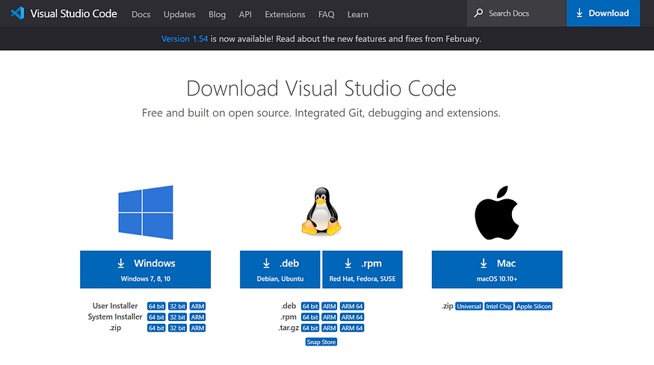

Step-2: Click on the download Option based on the Operating system.

Step-3: Click on the downloaded file to Install.

Step-4: Accept the agreement and click on “Next”.
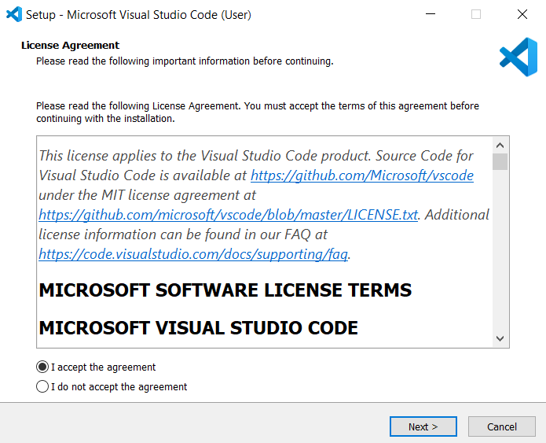

Step-5: Select a folder. Click “Next”.
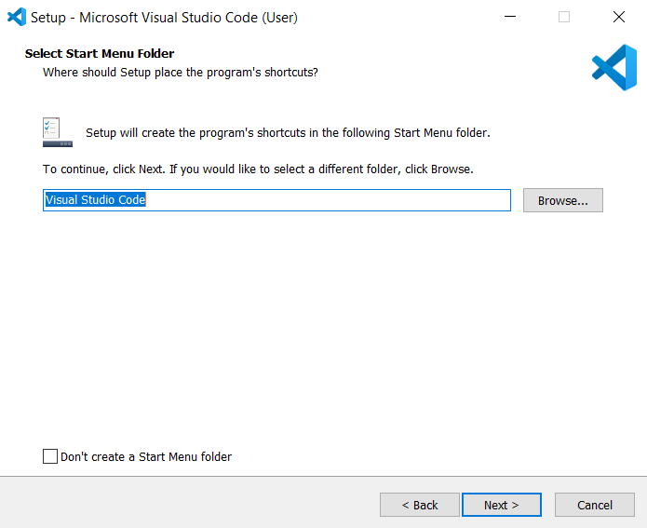

Step-6: Select the required options and click “Next”.
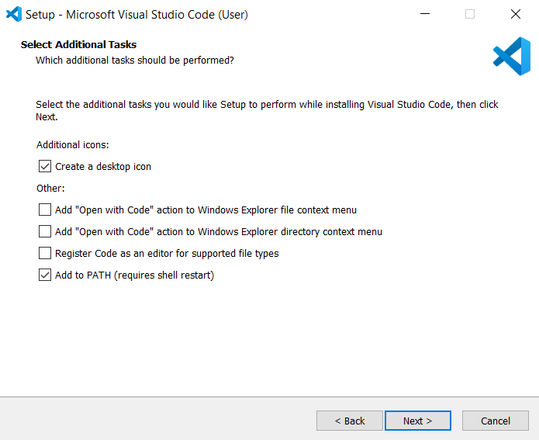

Step-7: Select “Install”.

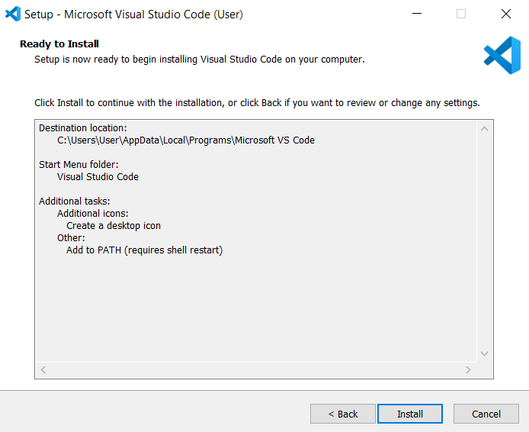
Step-8: Click “Finish” after installing successfully.

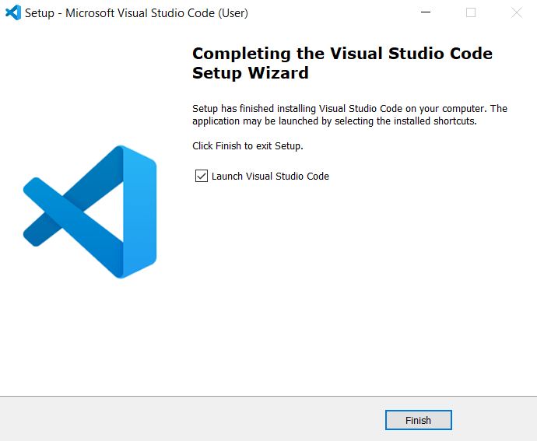

Step-9: Open VS code and go to Extensions tab on the left side panel, search for “Open in browser” extension and download that extension.
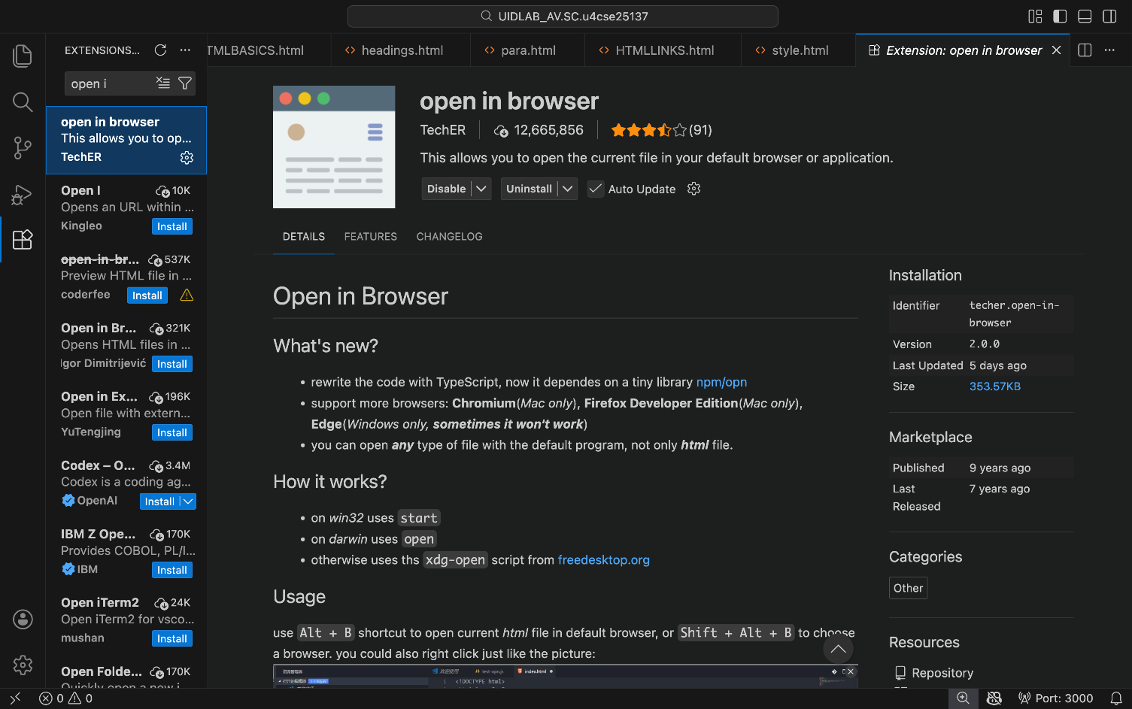
2.Aim: To understand the structure of HTML
Program:
Input:
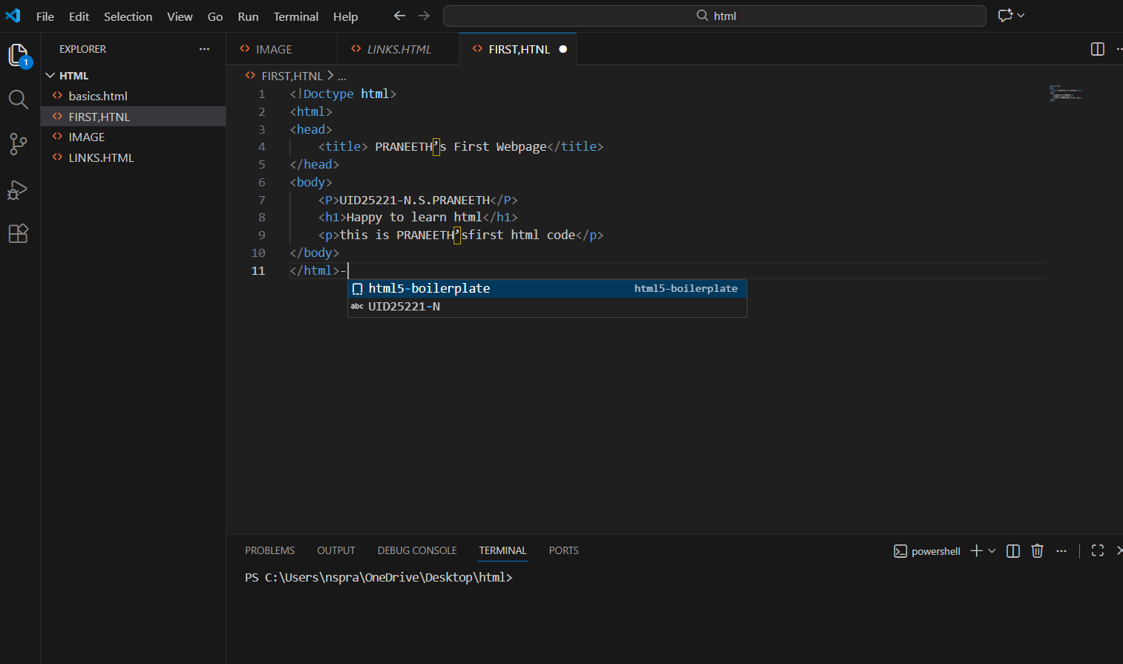
Output:
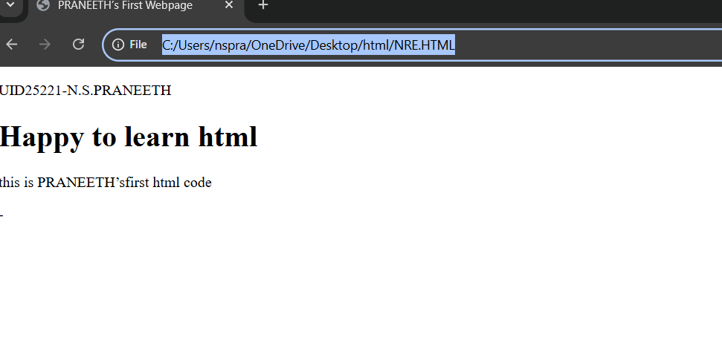

Explanation:
<!DOCTYPE html>
This tells the browser that the document is written in HTML5.

<html></html>
This is the main element of the HTML document.
Everything on the webpage goes inside this tag.

<head></head>
The head section contains meta information about the page.
Things here are not shown directly on the webpage.
This contains information that is applied to whole webpage like images or colour to the web page.

<title></title>
Sets the title of the webpage.
This text appears on the Browser tab.

<body></body>
This is the visible part of the webpage.
Everything the user sees (text, images, buttons, forms, etc.) goes here.
3.Aim: To understand the basic html tags
Program:
Input:
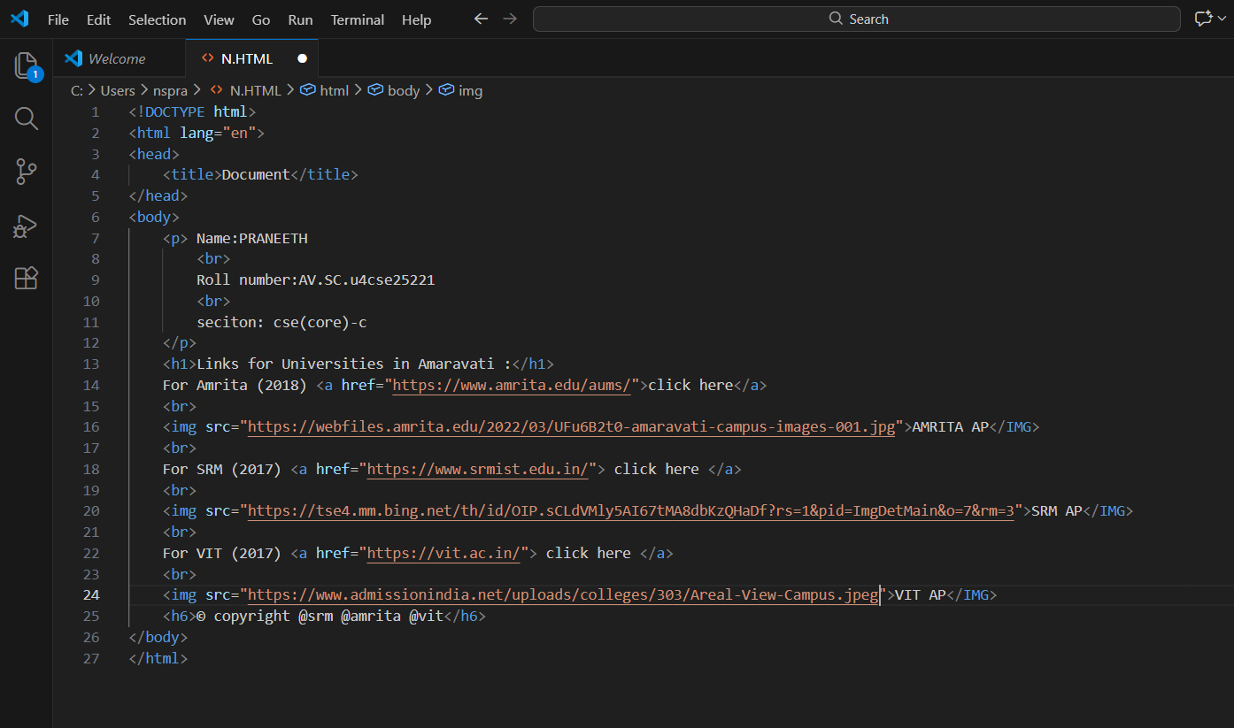
Output:
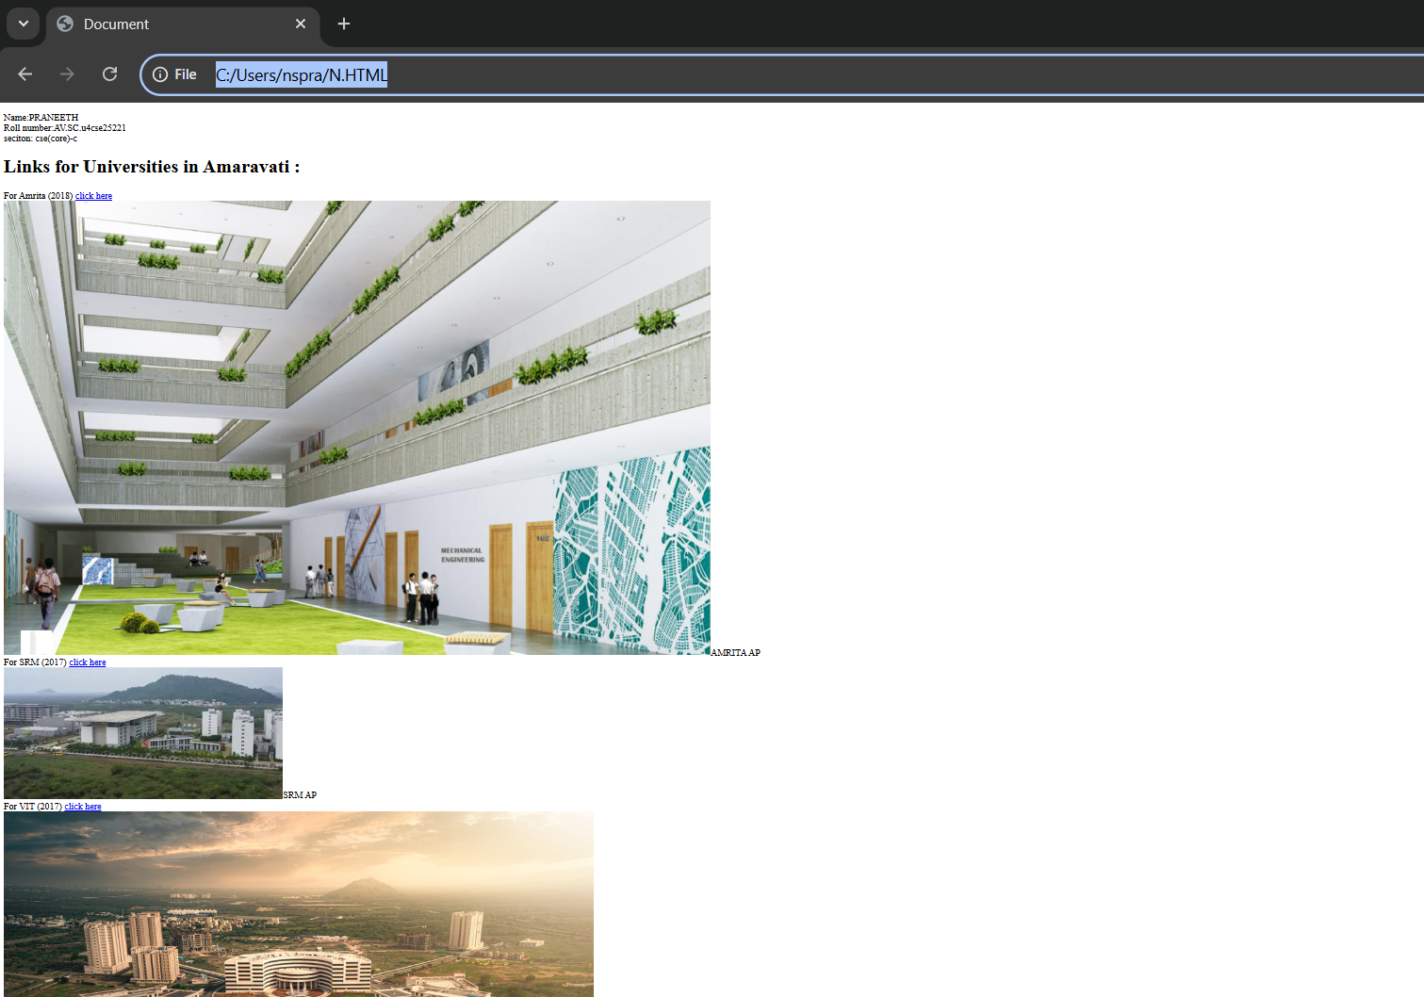

Explanation:

<h1></h1>
It Is Heading tag.
There are total of 6 heading tags from h1 to h6, h1 is highest and h6 is smallest.
Used for main titles of a page.

<p></p>
Paragraph tag.
Used for normal text content.
Any extra spaces than 1 space is removed automatically in-between sentence.

<a href=""></a>
Anchor tag → used to create links.
href = Hypertext Reference (link address).

<br>
It is Line break tag.
Moves content to the next line.
It has no closing tag.

<img>
Used to display images.
“src” attribute contains source of image (image URL).
“alt” attribute contains alternate text to display if image is not displayed.
“width” and “height” attributes of the image are also passed into this tag.

Week-2
AIM :
2(a):create the class timetable using HTML elements
CODE :

<html>
<head>
<title> timetable</title>
</head>
<table border="3">
<caption style="background-color: yellow;">SEM-2 TIMETABLE</caption>
<tr>
<th>DEPT.CSE </th>
<th rowspan="3" colspan="10">ROOM VENUE 512</th>
</tr>
<tr>
<th>CLASS BTECH CSE-C</th>
</tr>
<th>SEMESTER-2</th>
<tr>
<th style="font-family: 'Lucida Sans', 'Lucida Sans Regular', 'Lucida Grande', 'Lucida Sans Unicode', Geneva, Verdana, sans-serif;" colspan="3"> Advisors:
Name: Mr. Budati Jaya Lakshminarayana
Email : bj_lakshminarayana@av.amrita.edu
Mobile Number :+91-7989795768 </th>

<th style = "font-family: 'Lucida Sans', 'Lucida Sans Regular', 'Lucida Grande', 'Lucida Sans Unicode', Geneva, Verdana, sans-serif;"="8"> Name: Dr. Arun Kumar S
Email : s_arunkumar@av.amrita.edu
Mobile Number : +91-8940857202</th>
</tr>
</table>
<table border="3" style="border-collapse: collapse;">
<tr>

<th rowspan="2">TIME TABLE</th>
<th>SLOT-1</th>
<th>SLOT-2</th>
<th>SLOT-3</th>
<th>SLOT-4</th>
<th>SLOT-5</th>
<th>SLOT-6</th>
<th>SLOT-7</th>
<th>SLOT-8</th>
<th>SLOT-9</th>
<th>SLOT-10</th>

</tr>
<tr>
<th>8:50-9:40</th>
<th>9:40-10:30</th>
<th>10:30-10:40</th>
<th>10:40-11:30</th>
<th>11:30-12:20</th>
<th>12:20-1:10</th>
<th>1:10-2:30</th>
<th>2:30-3:20</th>
<th>3:20-4:10</th>
<th>4:10-5:00</th>

</tr>
<tr>
<td>MONDAY</td>
<td colspan="2">23MAT116 Discrete Mathematics_lab2</td>
<td rowspan="5" style="background-color: yellow; writing-mode: vertical-lr; text-align: center ; ">short break</td>
<td>23PHY115 Modern physics</td>
<td>23CSE111Object
Oriented Programming</td>

<td >library</td>
<td rowspan="5" style="background-color: yellow;writing-mode: vertical-lr; text-align: center;"> lunch</td>
<td>library</td>
<td rowspan="5" style="background-color: yellow; writing-mode: vertical-lr; text-align: center;">short break</td>

<td colspan="2">Library/Sports</td>
<tr>
<td>TUESDAY</td>
<td colspan="2">23CSE113 User Interface Design LAB(BYOD)</td>

<td>23MAT117 Linear
Algebra</td>
<td>23MAT116 Discrete
Mathematics</td>
<td COUNSELLING style="color: red;">COUNSELLING</td>

<td>library </td>

<td colspan="2">22ADM111 Glimpses of Glorious India</td>

</tr>
<tr>
<td>WEDNESDAY</td>
<td> 23PHY115 Modern
Physics</td>
<TD>23CSE113 User Interface
Design</TD>

<td colspan="2">23MAT117 Linear Algebra_LAB(BYOD)</td>
<td COUNSELLING style="color: red;"> COUNSELLING</td>

<td>library</td>

<td colspan="2">Library/Sports</td>
</tr>
<tr>
<td>THRUSDAY</td>
<td>23CSE111Object
Oriented
Programming</td>
<td>23MAT116 Discrete
Mathematics</td>

<td colspan="2">23CSE111Object Oriented Programming
_Lab2</td>
<td>23MAT117 Linear
Algebra</td>

<td>23MEE115 Manufacturing
Practice LAB</td>

<td colspan="2">23MEE115 Manufacturing
Practice LAB</td>
<td></td>

</tr>
<tr>
<td>FRIDAY</td>
<td>23CSE111Object
Oriented
Programming</td>
<td>23MAT116 Discrete
Mathematics</td>

<td>23PHY115 Modern
Physics(T)</td>
<td>23CSE113 User
Interface Design</td>
<td>23MAT117 Linear
Algebra</td>

<td>22ADM111Glimpses of
Glorious India(P)</td>

<td colspan="2">Library/Sports</td>
</tr>

</tr>
<tr>
<br>

</tr>
</table>
<br>

<table border="3" width="100%">

<tr>
<th>course code</th>
<th>course name</th>
<th>L-T-P</th>
<th>credits</th>
<th>faculty name</th>
<th>assisting faculty</th>

</tr>
<tr>
<td>23MAT116</td>
<td>Discrete Mathematics</td>
<td> 3-0-2 </td>
<td>4</td>
<td> Dr.Srivivasa Rao Thota</td>
<td></td>

</tr>
<tr>
<td>23MAT117</td>
<td>Linear Algebra</td>
<td>3-0-2</td>
<td>4</td>
<td>Mr.Sapavat Bixapathi</td>
<td></td>

</tr>
<tr>
<td>23CSE111</td>
<td>Object Oriented Programmin</td>
<td>3-0-2</td>
<td>4</td>
<td>Dr.SATYA RAJENDRA SINGH R</td>
<td> Dr. Balaji TK</td>
</tr>
<tr>
<td>23PHY115</td>
<td>Modern Physics</td>
<td>2-1-0</td>
<td>3</td>
<td> Dr.Soumya</td>
<td></td>
</tr>
<tr>

<td>23CSE113</td>
<td>User Interface Design</td>
<td>2-0-2</td>
<td>3</td>
<td> Dr.Rajkumar Batchu</td>
<td> Mr. Barge Bharadwaj</td>
</tr>
<tr>
<td>23MEE115</td>
<td>Manufacturing practice</td>

<td>0-0-3</td>
<td>1</td>
<td>Dr. Sathies S.</td>
<td></td>
</tr>
<tr>
<td>22ADM111</td>
<td>Glimpses Of Glorious India</td>
<td>2-0-1</td>
<td>2</td>
<td> Dr. Siva Panuganti</td>
<td></td>

</tr>
<tr>
<td></td>
<td>Total (15L + 1Tut +12P =28 hrs)</td>
<td>15-1-12</td>
<td>21</td>
<td></td>

<td></td>
</tr>

</table>
</html>

2(b):create an HTML webpage that display syllabus of all subjects as an image format also that contain timetable
CODE:

<html>
<head>
<title> timetable</title>
</head>
<table border="3">
<caption style="background-color: yellow;">SEM-2 TIMETABLE</caption>
<tr>
<th>DEPT.CSE </th>
<th rowspan="3" colspan="10">ROOM VENUE 512</th>
</tr>
<tr>
<th>CLASS BTECH CSE-C</th>
</tr>
<th>SEMESTER-2</th>
<tr>
<th style="font-family: 'Lucida Sans', 'Lucida Sans Regular', 'Lucida Grande', 'Lucida Sans Unicode', Geneva, Verdana, sans-serif;" colspan="3"> Advisors:
Name: Mr. Budati Jaya Lakshminarayana
Email : bj_lakshminarayana@av.amrita.edu
Mobile Number :+91-7989795768 </th>

<th style = "font-family: 'Lucida Sans', 'Lucida Sans Regular', 'Lucida Grande', 'Lucida Sans Unicode', Geneva, Verdana, sans-serif;"="8"> Name: Dr. Arun Kumar S
Email : s_arunkumar@av.amrita.edu
Mobile Number : +91-8940857202</th>
</tr>
</table>
<table border="3" style="border-collapse: collapse;">
<tr>

<th rowspan="2">TIME TABLE</th>
<th>SLOT-1</th>
<th>SLOT-2</th>
<th>SLOT-3</th>
<th>SLOT-4</th>
<th>SLOT-5</th>
<th>SLOT-6</th>
<th>SLOT-7</th>
<th>SLOT-8</th>
<th>SLOT-9</th>
<th>SLOT-10</th>

</tr>
<tr>
<th>8:50-9:40</th>
<th>9:40-10:30</th>
<th>10:30-10:40</th>
<th>10:40-11:30</th>
<th>11:30-12:20</th>
<th>12:20-1:10</th>
<th>1:10-2:30</th>
<th>2:30-3:20</th>
<th>3:20-4:10</th>
<th>4:10-5:00</th>

</tr>
<tr>
<td>MONDAY</td>
<td colspan="2">23MAT116 Discrete Mathematics_lab2</td>
<td rowspan="5" style="background-color: yellow; writing-mode: vertical-lr; text-align: center ; ">short break</td>
<td>23PHY115 Modern physics</td>
<td>23CSE111Object
Oriented Programming</td>

<td >library</td>
<td rowspan="5" style="background-color: yellow;writing-mode: vertical-lr; text-align: center;"> lunch</td>
<td>library</td>
<td rowspan="5" style="background-color: yellow; writing-mode: vertical-lr; text-align: center;">short break</td>

<td colspan="2">Library/Sports</td>
<tr>
<td>TUESDAY</td>
<td colspan="2">23CSE113 User Interface Design LAB(BYOD)</td>

<td>23MAT117 Linear
Algebra</td>
<td>23MAT116 Discrete
Mathematics</td>
<td COUNSELLING style="color: red;">COUNSELLING</td>

<td>library </td>

<td colspan="2">22ADM111 Glimpses of Glorious India</td>

</tr>
<tr>
<td>WEDNESDAY</td>
<td> 23PHY115 Modern
Physics</td>
<TD>23CSE113 User Interface
Design</TD>

<td colspan="2">23MAT117 Linear Algebra_LAB(BYOD)</td>
<td COUNSELLING style="color: red;"> COUNSELLING</td>

<td>library</td>

<td colspan="2">Library/Sports</td>
</tr>
<tr>
<td>THRUSDAY</td>
<td>23CSE111Object
Oriented
Programming</td>
<td>23MAT116 Discrete
Mathematics</td>

<td colspan="2">23CSE111Object Oriented Programming
_Lab2</td>
<td>23MAT117 Linear
Algebra</td>

<td>23MEE115 Manufacturing
Practice LAB</td>

<td colspan="2">23MEE115 Manufacturing
Practice LAB</td>
<td></td>

</tr>
<tr>
<td>FRIDAY</td>
<td>23CSE111Object
Oriented
Programming</td>
<td>23MAT116 Discrete
Mathematics</td>

<td>23PHY115 Modern
Physics(T)</td>
<td>23CSE113 User
Interface Design</td>
<td>23MAT117 Linear
Algebra</td>

<td>22ADM111Glimpses of
Glorious India(P)</td>

<td colspan="2">Library/Sports</td>
</tr>

</tr>
<tr>
<br>

</tr>
</table>
<br>

<table border="3" width="100%">

<tr>
<th>course code</th>
<th>course name</th>
<th>L-T-P</th>
<th>credits</th>
<th>faculty name</th>
<th>assisting faculty</th>

</tr>
<tr>
<td>23MAT116</td>
<td>Discrete Mathematics</td>
<td> 3-0-2 </td>
<td>4</td>
<td> Dr.Srivivasa Rao Thota</td>
<td></td>

</tr>
<tr>
<td>23MAT117</td>
<td>Linear Algebra</td>
<td>3-0-2</td>
<td>4</td>
<td>Mr.Sapavat Bixapathi</td>
<td></td>

</tr>
<tr>
<td>23CSE111</td>
<td>Object Oriented Programmin</td>
<td>3-0-2</td>
<td>4</td>
<td>Dr.SATYA RAJENDRA SINGH R</td>
<td> Dr. Balaji TK</td>
</tr>
<tr>
<td>23PHY115</td>
<td>Modern Physics</td>
<td>2-1-0</td>
<td>3</td>
<td> Dr.Soumya</td>
<td></td>
</tr>
<tr>

<td>23CSE113</td>
<td>User Interface Design</td>
<td>2-0-2</td>
<td>3</td>
<td> Dr.Rajkumar Batchu</td>
<td> Mr. Barge Bharadwaj</td>
</tr>
<tr>
<td>23MEE115</td>
<td>Manufacturing practice</td>

<td>0-0-3</td>
<td>1</td>
<td>Dr. Sathies S.</td>
<td></td>
</tr>
<tr>
<td>22ADM111</td>
<td>Glimpses Of Glorious India</td>
<td>2-0-1</td>
<td>2</td>
<td> Dr. Siva Panuganti</td>
<td></td>

</tr>
<tr>
<td></td>
<td>Total (15L + 1Tut +12P =28 hrs)</td>
<td>15-1-12</td>
<td>21</td>
<td></td>

<td></td>
</tr>

</table>

<h1 style="text-align: center;">Syllabus</h1>
<h2 style="color: rgb(0, 0, 0);">Discrete mathematics</h2>
<img src="c:\Users\nspra\OneDrive\Pictures\WhatsApp Image 2026-02-12 at 22.23.39.jpeg">
<h2 style="color: rgb(0, 0, 0);">Linear Algebra</h2>
<img src="c:\Users\nspra\OneDrive\Pictures\WhatsApp Image 2026-02-12 at 22.23.42 (1).jpeg">
<h2 style="color: rgb(0, 0, 0);">User interface design</h2>
<img src="c:\Users\nspra\OneDrive\Pictures\WhatsApp Image 2026-02-12 at 22.23.39 (1).jpeg">
<h2 style="color: rgb(0, 0, 0);">Manufacturing practice</h2>
<img src="c:\Users\nspra\OneDrive\Pictures\WhatsApp Image 2026-02-12 at 22.23.40.jpeg">
<h2 style="color: rgb(0, 0, 0);">Object oriented programming</h2>
<img src="c:\Users\nspra\OneDrive\Pictures\WhatsApp Image 2026-02-12 at 22.23.40 (1).jpeg">
<h2 style="color: rgb(0, 0, 0);">Modren Physics</h2>
<img src="c:\Users\nspra\Downloads\modern.png">
<h2 style="color: rgb(0, 0, 0);">Glimpses of glorious india</h2>
<img src="c:\Users\nspra\OneDrive\Pictures\WhatsApp Image 2026-02-12 at 22.23.42.jpeg">
</html>

WEEK-3
AIM 3(a):create the class timetable using HTML elements
CODE:
<html>
<head>
<title> timetable</title>
</head>
<table border="3">
<caption style="background-color: yellow;">SEM-2 TIMETABLE</caption>
<tr>
<th>DEPT.CSE </th>
<th rowspan="3" colspan="10">ROOM VENUE 512</th>
</tr>
<tr>
<th>CLASS BTECH CSE-C</th>
</tr>
<th>SEMESTER-2</th>
<tr>
<th style="font-family: 'Lucida Sans', 'Lucida Sans Regular', 'Lucida Grande', 'Lucida Sans Unicode', Geneva, Verdana, sans-serif;" colspan="3"> Advisors:
Name: Mr. Budati Jaya Lakshminarayana
Email : bj_lakshminarayana@av.amrita.edu
Mobile Number :+91-7989795768 </th>

<th style = "font-family: 'Lucida Sans', 'Lucida Sans Regular', 'Lucida Grande', 'Lucida Sans Unicode', Geneva, Verdana, sans-serif;"="8"> Name: Dr. Arun Kumar S
Email : s_arunkumar@av.amrita.edu
Mobile Number : +91-8940857202</th>
</tr>
</table>
<table border="3" style="border-collapse: collapse;">
<tr>

<th rowspan="2">TIME TABLE</th>
<th>SLOT-1</th>
<th>SLOT-2</th>
<th>SLOT-3</th>
<th>SLOT-4</th>
<th>SLOT-5</th>
<th>SLOT-6</th>
<th>SLOT-7</th>
<th>SLOT-8</th>
<th>SLOT-9</th>
<th>SLOT-10</th>

</tr>
<tr>
<th>8:50-9:40</th>
<th>9:40-10:30</th>
<th>10:30-10:40</th>
<th>10:40-11:30</th>
<th>11:30-12:20</th>
<th>12:20-1:10</th>
<th>1:10-2:30</th>
<th>2:30-3:20</th>
<th>3:20-4:10</th>
<th>4:10-5:00</th>

</tr>
<tr>
<td>MONDAY</td>
<td colspan="2">23MAT116 Discrete Mathematics_lab2</td>
<td rowspan="5" style="background-color: yellow; writing-mode: vertical-lr; text-align: center ; ">short break</td>
<td>23PHY115 Modern physics</td>
<td>23CSE111Object
Oriented Programming</td>

<td >library</td>
<td rowspan="5" style="background-color: yellow;writing-mode: vertical-lr; text-align: center;"> lunch</td>
<td>library</td>
<td rowspan="5" style="background-color: yellow; writing-mode: vertical-lr; text-align: center;">short break</td>

<td colspan="2">Library/Sports</td>
<tr>
<td>TUESDAY</td>
<td colspan="2">23CSE113 User Interface Design LAB(BYOD)</td>

<td>23MAT117 Linear
Algebra</td>
<td>23MAT116 Discrete
Mathematics</td>
<td COUNSELLING style="color: red;">COUNSELLING</td>

<td>library </td>

<td colspan="2">22ADM111 Glimpses of Glorious India</td>

</tr>
<tr>
<td>WEDNESDAY</td>
<td> 23PHY115 Modern
Physics</td>
<TD>23CSE113 User Interface
Design</TD>

<td colspan="2">23MAT117 Linear Algebra_LAB(BYOD)</td>
<td COUNSELLING style="color: red;"> COUNSELLING</td>

<td>library</td>

<td colspan="2">Library/Sports</td>
</tr>
<tr>
<td>THRUSDAY</td>
<td>23CSE111Object
Oriented
Programming</td>
<td>23MAT116 Discrete
Mathematics</td>

<td colspan="2">23CSE111Object Oriented Programming
_Lab2</td>
<td>23MAT117 Linear
Algebra</td>

<td>23MEE115 Manufacturing
Practice LAB</td>

<td colspan="2">23MEE115 Manufacturing
Practice LAB</td>
<td></td>

</tr>
<tr>
<td>FRIDAY</td>
<td>23CSE111Object
Oriented
Programming</td>
<td>23MAT116 Discrete
Mathematics</td>

<td>23PHY115 Modern
Physics(T)</td>
<td>23CSE113 User
Interface Design</td>
<td>23MAT117 Linear
Algebra</td>

<td>22ADM111Glimpses of
Glorious India(P)</td>

<td colspan="2">Library/Sports</td>
</tr>

</tr>
<tr>
<br>

</tr>
</table>
<br>

<table border="3" width="100%">

<tr>
<th>course code</th>
<th>course name</th>
<th>L-T-P</th>
<th>credits</th>
<th>faculty name</th>
<th>assisting faculty</th>

</tr>
<tr>
<td>23MAT116</td>
<td>Discrete Mathematics</td>
<td> 3-0-2 </td>
<td>4</td>
<td> Dr.Srivivasa Rao Thota</td>
<td></td>

</tr>
<tr>
<td>23MAT117</td>
<td>Linear Algebra</td>
<td>3-0-2</td>
<td>4</td>
<td>Mr.Sapavat Bixapathi</td>
<td></td>

</tr>
<tr>
<td>23CSE111</td>
<td>Object Oriented Programmin</td>
<td>3-0-2</td>
<td>4</td>
<td>Dr.SATYA RAJENDRA SINGH R</td>
<td> Dr. Balaji TK</td>
</tr>
<tr>
<td>23PHY115</td>
<td>Modern Physics</td>
<td>2-1-0</td>
<td>3</td>
<td> Dr.Soumya</td>
<td></td>
</tr>
<tr>

<td>23CSE113</td>
<td>User Interface Design</td>
<td>2-0-2</td>
<td>3</td>
<td> Dr.Rajkumar Batchu</td>
<td> Mr. Barge Bharadwaj</td>
</tr>
<tr>
<td>23MEE115</td>
<td>Manufacturing practice</td>

<td>0-0-3</td>
<td>1</td>
<td>Dr. Sathies S.</td>
<td></td>
</tr>
<tr>
<td>22ADM111</td>
<td>Glimpses Of Glorious India</td>
<td>2-0-1</td>
<td>2</td>
<td> Dr. Siva Panuganti</td>
<td></td>

</tr>
<tr>
<td></td>
<td>Total (15L + 1Tut +12P =28 hrs)</td>
<td>15-1-12</td>
<td>21</td>
<td></td>

<td></td>
</tr>

</table>
</html>
OUTPUT:
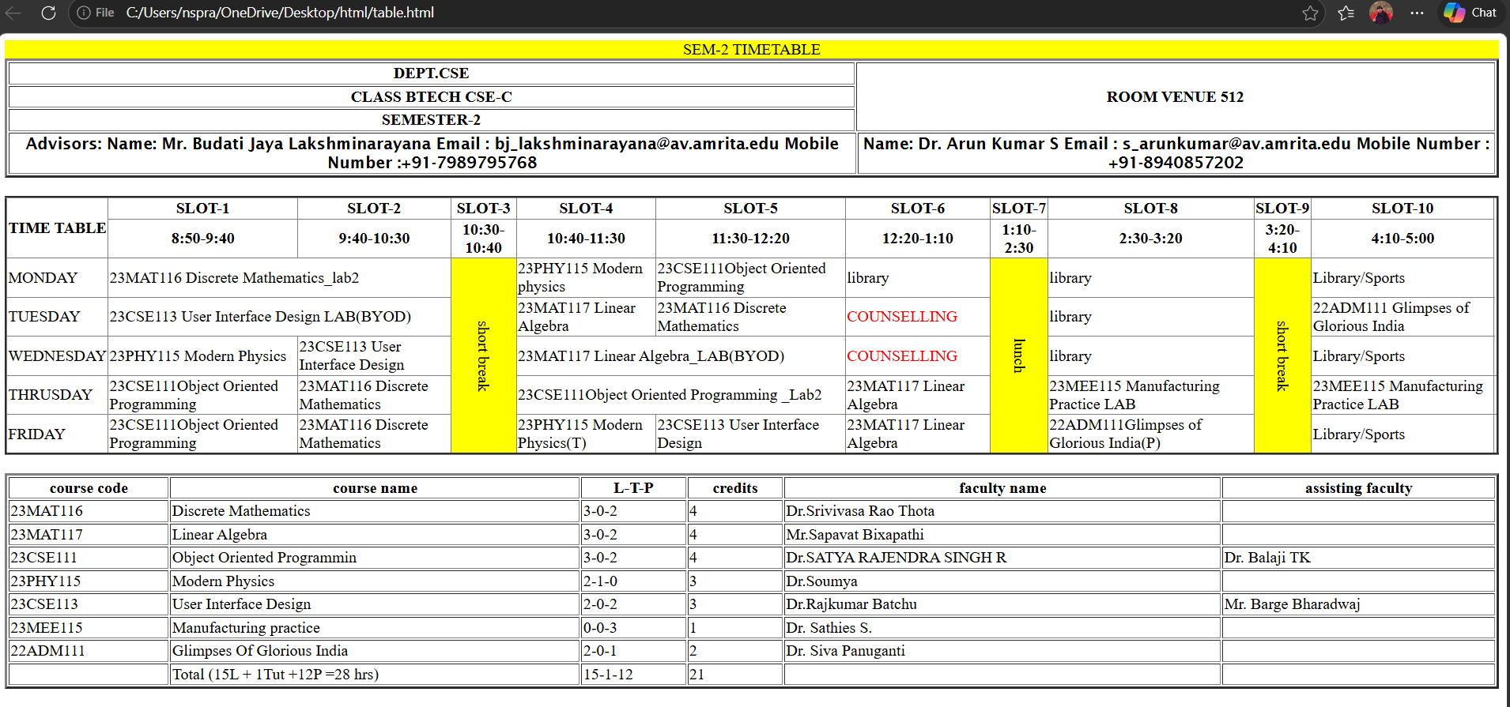

3(b):create an HTML webpage that display syllabus of all the subjects as an image format al;so that contains timetable
CODE:
<html>
<head>
<title> timetable</title>
</head>
<table border="3">
<caption style="background-color: yellow;">SEM-2 TIMETABLE</caption>
<tr>
<th>DEPT.CSE </th>
<th rowspan="3" colspan="10">ROOM VENUE 512</th>
</tr>
<tr>
<th>CLASS BTECH CSE-C</th>
</tr>
<th>SEMESTER-2</th>
<tr>
<th style="font-family: 'Lucida Sans', 'Lucida Sans Regular', 'Lucida Grande', 'Lucida Sans Unicode', Geneva, Verdana, sans-serif;" colspan="3"> Advisors:
Name: Mr. Budati Jaya Lakshminarayana
Email : bj_lakshminarayana@av.amrita.edu
Mobile Number :+91-7989795768 </th>

<th style = "font-family: 'Lucida Sans', 'Lucida Sans Regular', 'Lucida Grande', 'Lucida Sans Unicode', Geneva, Verdana, sans-serif;"="8"> Name: Dr. Arun Kumar S
Email : s_arunkumar@av.amrita.edu
Mobile Number : +91-8940857202</th>
</tr>
</table>
<table border="3" style="border-collapse: collapse;">
<tr>

<th rowspan="2">TIME TABLE</th>
<th>SLOT-1</th>
<th>SLOT-2</th>
<th>SLOT-3</th>
<th>SLOT-4</th>
<th>SLOT-5</th>
<th>SLOT-6</th>
<th>SLOT-7</th>
<th>SLOT-8</th>
<th>SLOT-9</th>
<th>SLOT-10</th>

</tr>
<tr>
<th>8:50-9:40</th>
<th>9:40-10:30</th>
<th>10:30-10:40</th>
<th>10:40-11:30</th>
<th>11:30-12:20</th>
<th>12:20-1:10</th>
<th>1:10-2:30</th>
<th>2:30-3:20</th>
<th>3:20-4:10</th>
<th>4:10-5:00</th>

</tr>
<tr>
<td>MONDAY</td>
<td colspan="2">23MAT116 Discrete Mathematics_lab2</td>
<td rowspan="5" style="background-color: yellow; writing-mode: vertical-lr; text-align: center ; ">short break</td>
<td>23PHY115 Modern physics</td>
<td>23CSE111Object
Oriented Programming</td>

<td >library</td>
<td rowspan="5" style="background-color: yellow;writing-mode: vertical-lr; text-align: center;"> lunch</td>
<td>library</td>
<td rowspan="5" style="background-color: yellow; writing-mode: vertical-lr; text-align: center;">short break</td>

<td colspan="2">Library/Sports</td>
<tr>
<td>TUESDAY</td>
<td colspan="2">23CSE113 User Interface Design LAB(BYOD)</td>

<td>23MAT117 Linear
Algebra</td>
<td>23MAT116 Discrete
Mathematics</td>
<td COUNSELLING style="color: red;">COUNSELLING</td>

<td>library </td>

<td colspan="2">22ADM111 Glimpses of Glorious India</td>

</tr>
<tr>
<td>WEDNESDAY</td>
<td> 23PHY115 Modern
Physics</td>
<TD>23CSE113 User Interface
Design</TD>

<td colspan="2">23MAT117 Linear Algebra_LAB(BYOD)</td>
<td COUNSELLING style="color: red;"> COUNSELLING</td>

<td>library</td>

<td colspan="2">Library/Sports</td>
</tr>
<tr>
<td>THRUSDAY</td>
<td>23CSE111Object
Oriented
Programming</td>
<td>23MAT116 Discrete
Mathematics</td>

<td colspan="2">23CSE111Object Oriented Programming
_Lab2</td>
<td>23MAT117 Linear
Algebra</td>

<td>23MEE115 Manufacturing
Practice LAB</td>

<td colspan="2">23MEE115 Manufacturing
Practice LAB</td>
<td></td>

</tr>
<tr>
<td>FRIDAY</td>
<td>23CSE111Object
Oriented
Programming</td>
<td>23MAT116 Discrete
Mathematics</td>

<td>23PHY115 Modern
Physics(T)</td>
<td>23CSE113 User
Interface Design</td>
<td>23MAT117 Linear
Algebra</td>

<td>22ADM111Glimpses of
Glorious India(P)</td>

<td colspan="2">Library/Sports</td>
</tr>

</tr>
<tr>
<br>

</tr>
</table>
<br>

<table border="3" width="100%">

<tr>
<th>course code</th>
<th>course name</th>
<th>L-T-P</th>
<th>credits</th>
<th>faculty name</th>
<th>assisting faculty</th>

</tr>
<tr>
<td>23MAT116</td>
<td>Discrete Mathematics</td>
<td> 3-0-2 </td>
<td>4</td>
<td> Dr.Srivivasa Rao Thota</td>
<td></td>

</tr>
<tr>
<td>23MAT117</td>
<td>Linear Algebra</td>
<td>3-0-2</td>
<td>4</td>
<td>Mr.Sapavat Bixapathi</td>
<td></td>

</tr>
<tr>
<td>23CSE111</td>
<td>Object Oriented Programmin</td>
<td>3-0-2</td>
<td>4</td>
<td>Dr.SATYA RAJENDRA SINGH R</td>
<td> Dr. Balaji TK</td>
</tr>
<tr>
<td>23PHY115</td>
<td>Modern Physics</td>
<td>2-1-0</td>
<td>3</td>
<td> Dr.Soumya</td>
<td></td>
</tr>
<tr>

<td>23CSE113</td>
<td>User Interface Design</td>
<td>2-0-2</td>
<td>3</td>
<td> Dr.Rajkumar Batchu</td>
<td> Mr. Barge Bharadwaj</td>
</tr>
<tr>
<td>23MEE115</td>
<td>Manufacturing practice</td>

<td>0-0-3</td>
<td>1</td>
<td>Dr. Sathies S.</td>
<td></td>
</tr>
<tr>
<td>22ADM111</td>
<td>Glimpses Of Glorious India</td>
<td>2-0-1</td>
<td>2</td>
<td> Dr. Siva Panuganti</td>
<td></td>

</tr>
<tr>
<td></td>
<td>Total (15L + 1Tut +12P =28 hrs)</td>
<td>15-1-12</td>
<td>21</td>
<td></td>
<td></td>
</tr>

</table>

<h1 style="text-align: center;">Syllabus</h1>
<h2 style="color: rgb(0, 0, 0);">Discrete mathematics</h2>
<img src="c:\Users\nspra\OneDrive\Pictures\WhatsApp Image 2026-02-12 at 22.23.39.jpeg">
<h2 style="color: rgb(0, 0, 0);">Linear Algebra</h2>
<img src="c:\Users\nspra\OneDrive\Pictures\WhatsApp Image 2026-02-12 at 22.23.42 (1).jpeg">
<h2 style="color: rgb(0, 0, 0);">User interface design</h2>
<img src="c:\Users\nspra\OneDrive\Pictures\WhatsApp Image 2026-02-12 at 22.23.39 (1).jpeg">
<h2 style="color: rgb(0, 0, 0);">Manufacturing practice</h2>
<img src="c:\Users\nspra\OneDrive\Pictures\WhatsApp Image 2026-02-12 at 22.23.40.jpeg">
<h2 style="color: rgb(0, 0, 0);">Object oriented programming</h2>
<img src="c:\Users\nspra\OneDrive\Pictures\WhatsApp Image 2026-02-12 at 22.23.40 (1).jpeg">
<h2 style="color: rgb(0, 0, 0);">Modren Physics</h2>
<img src="c:\Users\nspra\Downloads\modern.png">
<h2 style="color: rgb(0, 0, 0);">Glimpses of glorious india</h2>
<img src="c:\Users\nspra\OneDrive\Pictures\WhatsApp Image 2026-02-12 at 22.23.42.jpeg">
</html>

OUTPUT:
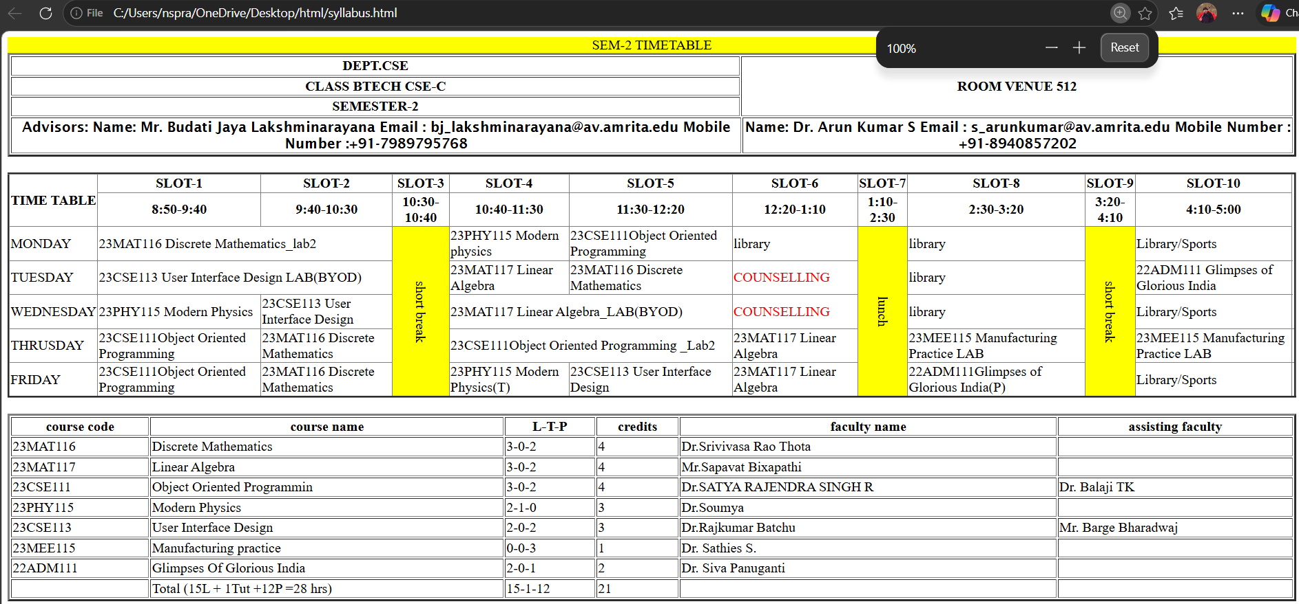
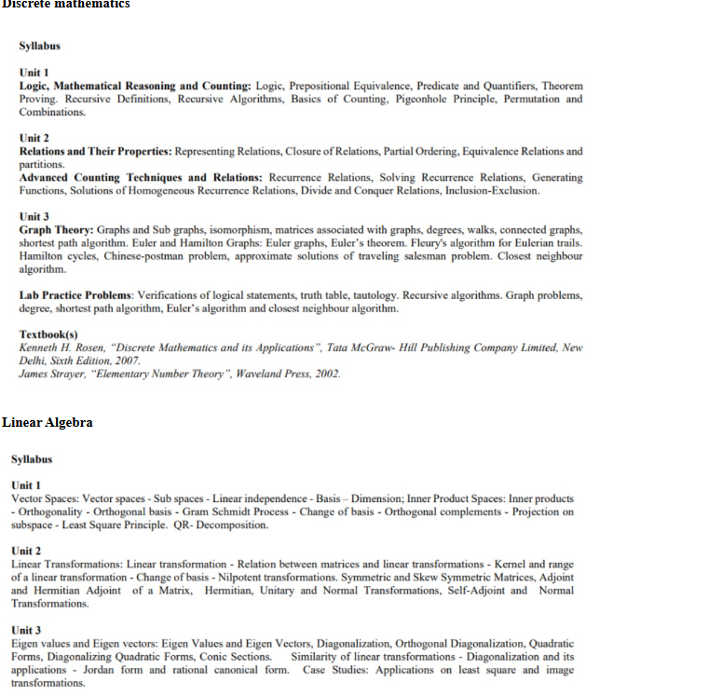
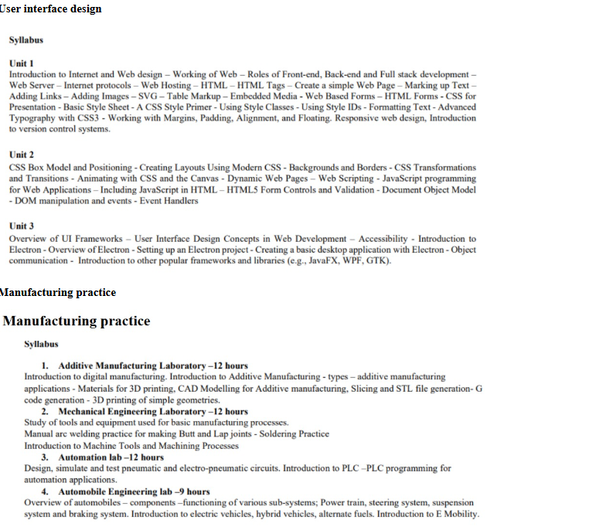

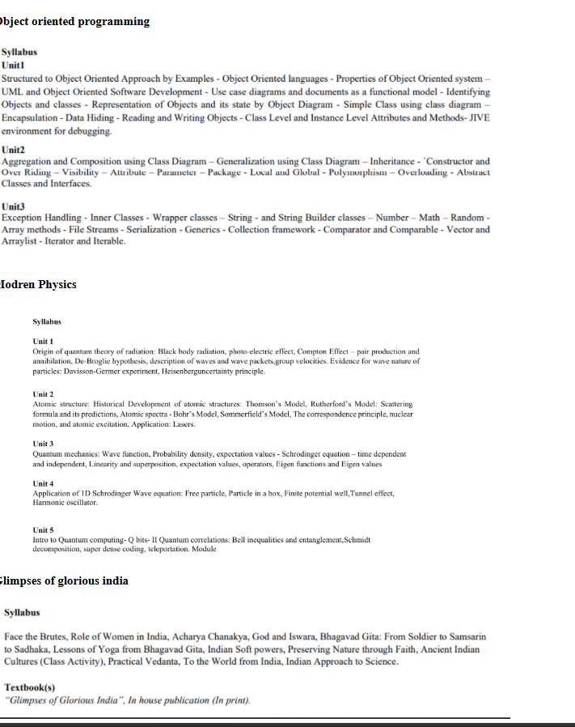

Explanation:
1. <table> = the <table> tag is used to arrange data into rows and columns.
2. <tr> = Creates a horizontal row.
3. <th> = Defines a header cell (usually bold and centred by default).
4. <td> = the <td> tag stands for table Data.
5. <b> = Used for bold text.
6. colspan attribute = It is used to merge multiple columns across horizontally.
7. rowspan attribute = It is used to merge multiple rows across vertically.

WEEK-4
AIM : Creating a collage registration form using HTML.
CODE :
<!DOCTYPE html>
<html>
<body>
<center>
<h1 align="center">College Admission Registration</h1>
<form>
<table width="600" border="1" cellpadding="10" cellspacing="0" style="text-align:center;">
<tr>
<td>
<label for="Full name">Full Name:</label>
</td>
<td>
<input type="text" id="Full name" name="Full name">
</td>
</tr>
<tr>
<td>
<label for="email">Email:</label>
</td>
<td>
<input type="text" id="email" name="email">
</td>
</tr>
<tr>
<td>
<label for="phone number">Phone Number:</label>
</td>
<td>
<input type="text" id="phone number" name="phone nummber">
</td>
</tr>
<tr>
<td>
<label for="Gender">Gender:</label>
</td>
<td>
<label for="male">Male</label>
<input type="radio" id="male" name="male" value="male">
<label for="female">Female</label>
<input type="radio" id="female" name="male" value="female">
<label for="other">Other</label>
<input type="radio" id="other" name="male" value="other">
</td>
</tr>
<tr>
<td>
<label for="Course Applying For">Course Applying For:</label>
</td>
<td>
<select id="course" name="course">
<option value="">--Select--</option>
<option value="Btech">Btech</option>
<option value="B.Sc">B.Sc</option>
<option value="B.Com">B.Com</option>
<option value="BBA">BBA</option>
<option value="M.Tech">M.Tech</option>
</select>
</td>
</tr>
<tr>
<td>
<label for="Hobbies">Hobbies:</label>
</td>
<td>
<label for="Sports">Sports</label>
<input type="checkbox" id="sports" name="sports" value="sports">
<label for="Music">Music</label>
<input type="checkbox" id="" name="music" value="music">
<label for="Reading">Reading</label>
<input type="checkbox" id="reading" name="reading" value="reading">
</td>
</tr>
<tr>
<td>
<label for="Date Of Birth">Date Of Birth:</label>
</td>
<td>
<input type="date" name="datemax" min="" max="">
</td>
</tr>
<tr>
<td>
<label for="my file">Upload Certificates:</label>
</td>
<td>
<input type="file" id="my file" name="my file" multiple>
</td>
</tr>
<tr>
<td>
<label for="address">Address:</label>
</td>
<td>
<textarea name="address" id="address" rows="5" cols="30"></textarea>
</td>
</tr>
<tr>
<td colspan="2" style:align="center">
<input type="Submit" id="Submit" name="Submit" value="Submit">
<input type="Reset" id="Reset" name="Reset" value="Reset">
</td>
</tr>
</form>
</center>
</body>
</html>

OUTPUT:
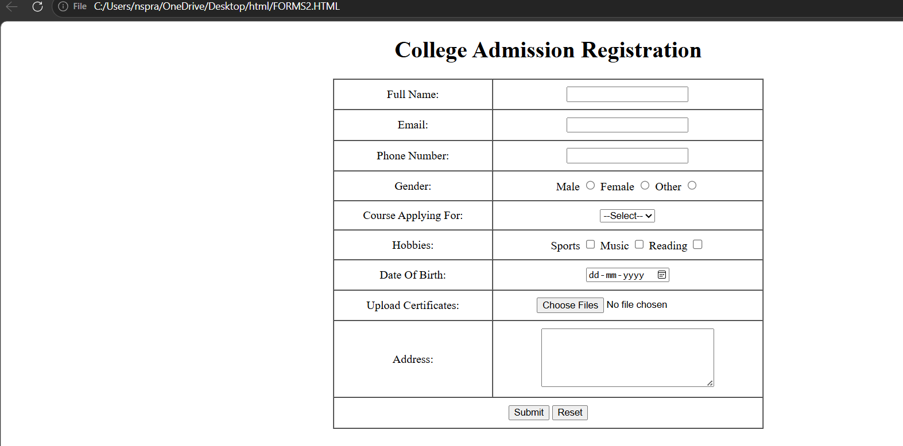

2. Create two different forms in one webpage using Iframes.
CODE:
<!DOCTYPE html>
<html>
<head>
<title>Two Forms Using Iframes</title>
</head>
<body>
<center>
<h2>Two Forms Using Iframes</h2>
<iframe src="User Login form.html" width="600" height="500"></iframe>
<iframe src="User Registration.html" width="600" height="500"></iframe>
</center>
</body>
</html>

USER LOGIN FORM:

<!DOCTYPE html>
<html>
<body>
<center>
<h2>User Login</h2>
<form>
<tr>
<table width="50" border="1" cellpadding="25" cellspacing="2" style="text-align:center;">
<tr>
<td>
<label for="fname">Username:</label>
</td>
<td>
<input type="text" id="fname" name="fname">
</td>
</tr>
<td>
<label for="password">Password:</label>
</td>
<td>
<input type="password" id="password" name="password">
</td>
<tr>
<td colspan="2" style:align="center">
<input type="Submit" id="Login" name="Login" value="Login">
</td>
</tr>
</table>
</center>
</form>
</body>
</html>

USER REGISTRATION FORM:
USER REGISTRATION FORM:
<!DOCTYPE html>
<html>
<body>
<center>
<h2>User Registration</h2>
<form>
<table width="50" border="1" cellpadding="25" cellspacing="2" style="text-align:center;">
<tr>
<td>
<label for="fname">FullName:</label>
</td>
<td>
<input type="text" id="fname" name="fname">
</td>
</tr>
<td>
<label for="Email">Email:</label>
</td>
<td>
<input type="Email" id="Email" name="Email">
</td>
<tr>
<td>
<label for="phone number">Phone:</label>
</td>
<td>
<input type="text" id="phone number" name="phone nummber">
</td>
</tr>
<tr>
<td>
<label for="password">Password:</label>
</td>
<td>
<input type="password" id="password" name="password">
</td>
</tr>
<tr>
<td colspan="2" style:align="center">
<input type="Submit" id="Register" name="Register" value="Register">
<input type="Reset" id="Reset" name="Reset" value="Reset">
</td>
</tr>
</form>
</table>
</tr>
</center>
</body>
</html>

OUTPUT:
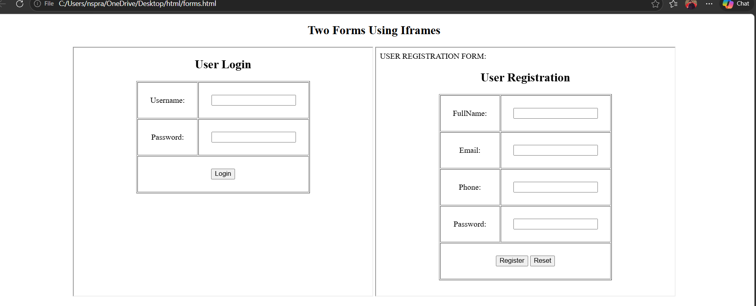

Explanation:
1. <label> = Provides a clickable text description that tells the user what information to enter.
2. <input> = Creates an interactive field where the user can actually type data or select options.
3. <iframe> = Acts as a window to display another website or HTML document inside your current page.
4. <centre> = Used to align content to the middle of the page.
5. Src = Tells the <iframe> exactly which file to display inside the window.
6. Type = Defines what kind of input to show (e.g., text for names, password to hide characters, or submit for a button).
7. Id = A unique name for an element that connects it to a <label>.
8. Name = The "key" or label sent to the
server so it knows which piece of data belongs to which field.
9. For = Used in a <label> to link it to the id of an <input>, making the label clickable.

WEEK-5
5.A)Aim: creating a card layout using tag consider three cards and a button using html and css.
<DOCTYPE html>
<html>
<head>
<style>
body{
background-color: #ffffff;

}
h1{
text-align: center;
font-family: 'Lucida Sans', 'Lucida Sans Regular', 'Lucida Grande', 'Lucida Sans Unicode', Geneva, Verdana, sans-serif;
}
.container {
display: flex;
justify-content: center;
gap: 25px;
padding: 40px;
background-color: #e9ecef;
border-radius: 15px;
margin: 20px;
}

.card {
background: #ffffff;
padding: 20px;;
max-width: 300px;
border-radius: 10px;
box-shadow: 0 4px 6px rgba(0,0,0,0.1);
text-align: center;
font-family: sans-serif;
}
.img{
width: 75%;
border-radius: 15px;
}

.click-me-box {
display: block;
margin: 15px auto 0;
padding: 10px;
background-color: #5148f9;
color: white;
border: none;
border-radius: 55px;
cursor: pointer;
font-weight: bold;
}

.click-me-box:hover {
background-color: #7094ff;
}
</style>
</head>
<body>
<h1>Trimurti</h1>

<div class="container">

<div class="card">
<h3>LORD VENKATESHWARA</h3>
<img src="uid1.jpg.jpeg" class="img">
<p>Lord Venkateswara, also known as Balaji, Srinivasa, or Venkatachalapati, is a revered form of Lord Vishnu worshipped primarily at the Tirumala Venkateswara Temple in Andhra Pradesh, India.</p>
<button class="click-me-box">Click Me</button>
</div>

<div class="card">
<h3>LORD SHIVA</h3>
<img src="uid2.jpg.jpeg" class=img>
<p>Lord Shiva, also known as Mahadev ("Great God"), is one of the most prominent deities in Hinduism</p>
<button class="click-me-box">Click Me</button>
</div>

<div class="card">
<h3>LORD BRAMHA</h3>
<img src="uid3.jpg.jpeg" class="img">
<p>Lord Brahma is the Creator god in the Hindu trinity, the Trimurti</p>
<button class="click-me-box">Click Me</button>
</div>

</div>
</body>
</html>
Explanation:
1. <div> = A <div> is an invisible container used to group HTML elements together so you can style them with CSS or manipulate them with JavaScript as a single unit.
2. <button> = we use <button> element for creating button.
3. Class = A class is a reusable identifier used to apply the same CSS styles.
4. Display : flex = Display flex is a CSS property used to easily align, gap, and distribute space among items within a container.
5. Gap = Gap is the external space between multiple items inside a Flex or Grid container.
6. Padding = Padding is the internal space inside an element (between its border and its content).
7. Cursor : pointer = Cursor pointer is a CSS property used to change the mouse icon into a hand with a pointing finger.
8. Margin = Margin is a CSS property used to create empty space around an element.
9. box-shadow: 0 4px 6px rgba(0,0,0,0.1) = box-shadow is used for creating a shadow around a box.
This page was created using interal css.

OUTPUT:
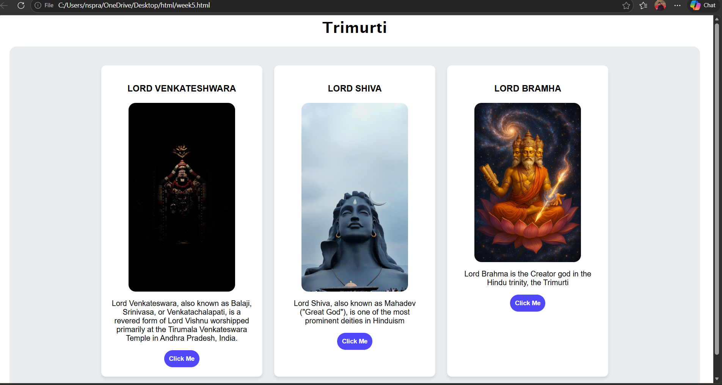

5.B)Aim: Navigation using iframe (mini website) upon clicking each buttons the details about that button should be display on the same page.
<!DOCTYPE html>

<html>

<head>

<style>

body{

background-color: rgb(220, 222, 221);

font-family:Arial;

}

.menu{

display:flex;

background-color: #ece4a8;

padding: 10px;

text-align: center;

justify-content: center;

border-radius: 15px;

}

.menu a{

color:white;

margin:0 15px;

text-decoration:none;

background:black;

padding:8px 12px;

text-align: center;

align-items: center;

align-content: center;

border-radius: 15px;

}

h1{

text-align:center;

background:#79ecfb;

color:rgb(0, 0, 0);

padding:20px;

font-family: cursive;

border-radius: 15px;

}

iframe{

width:100%;

height:4000px;

border:none;

}

pre{
font-size: x-large;
font-family: 'Courier New', Courier, monospace;
font-weight: bold;
margin: 20px;
}
</style>

</head>

<body>

<h1>VIRAT KOHLI</h1>

<div class="menu">

<a href="test.html" target="frame" class="menu a">Test</a>

<a href="odi.html" target="frame" class="menu a">ODI</a>

<a href="t20.html" target="frame" class="menu a">T20I</a>

</div>
<pre>

Virat Kohli (born November 5, 1988) is a legendary Indian international cricketer widely regarded as one of the best all-format batsmen in history.
A top-order right-handed batter and former captain, he is renowned for his "chase-master" ability, immense fitness, and aggressive style.
He led India to numerous victories and holds multiple international scoring records.
</pre>

</body>

<iframe name="frame"></iframe>

</html>

ODI.HTML:
<!DOCTYPE html>

<html>

<head>

<style>

body{

font-family:Arial;

text-align:center

}

.box{

border:2px solid black;

padding:20px;

display:inline-block;

border-radius: 15px;

}

h2{

color:#000000;

font-family: cursive;

}

pre{
font-family: Arial, Helvetica, sans-serif;
font-weight: bold;
}

</style>

</head>

<body>

<div class="box">

<h2>ODI CAREER</h2>

<pre>VIRAT KOHLI IS REGADED AS THE GOAT OF THE ERA.
Matches Played: 311 ODIs
Runs Scored: 14,747 runs
Batting Average: 58.2
Centuries: 77
Half-Centuries: 77
Highest Score: 183.

</pre>

<img src="test.jpg" alt="odi" >

</div>

</html>

T20.HTML:
<!DOCTYPE html>

<html>

<head>

<style>

body{

font-family:Arial;

text-align:center

}

.box{

border:2px solid black;

padding:20px;

display:inline-block;

border-radius: 15px;

}

h2{

color:#000000;

font-family: cursive;

}

pre{
font-family: Arial, Helvetica, sans-serif;
font-weight: bold;
}

</style>

</head>

<body>

<div class="box">

<h2>T20 CAREER</h2>

<pre>
VIRAT KOHLI IS REGADED AS THE GOAT OF THE ERA.
Matches Played: 125 T20s
Runs Scored: 4870 runs
Batting Average:48.7
Centuries: 1
Half-Centuries: 30
Highest Score: 122
</pre>

<img src="test.jpg" alt="odi" >

</div>

</html>

TEST.HTML:
<!DOCTYPE html>

<html>

<head>

<style>

body{

font-family:Arial;

text-align:center

}

.box{

border:2px solid black;

padding:20px;

display:inline-block;

border-radius: 15px;

}

h2{

color:#000000;

font-family: cursive;

}

pre{
font-family: Arial, Helvetica, sans-serif;
font-weight: bold;
}

</style>

</head>

<body>

<div class="box">

<h2>TEST CAREER</h2>

<pre>
VIRAT KOHLI IS REGADED AS THE GOAT OF THE ERA.
Matches Played: 123 TESTS
Runs Scored: 9740 runs
Batting Average: 49.4
Centuries: 30
Half-Centuries: 31
Highest Score: 264.
</pre>

<img src="test.jpg" alt="odi" >

</div>

</html>

OUTPUT:
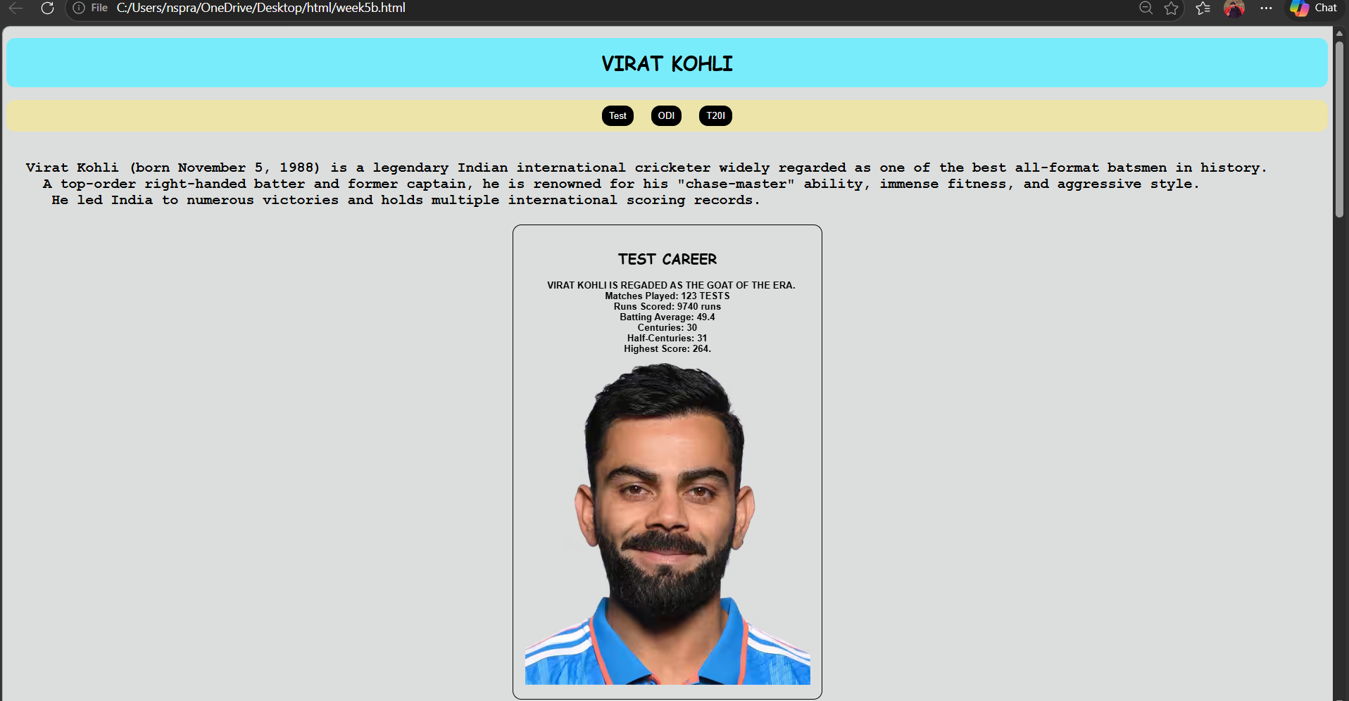
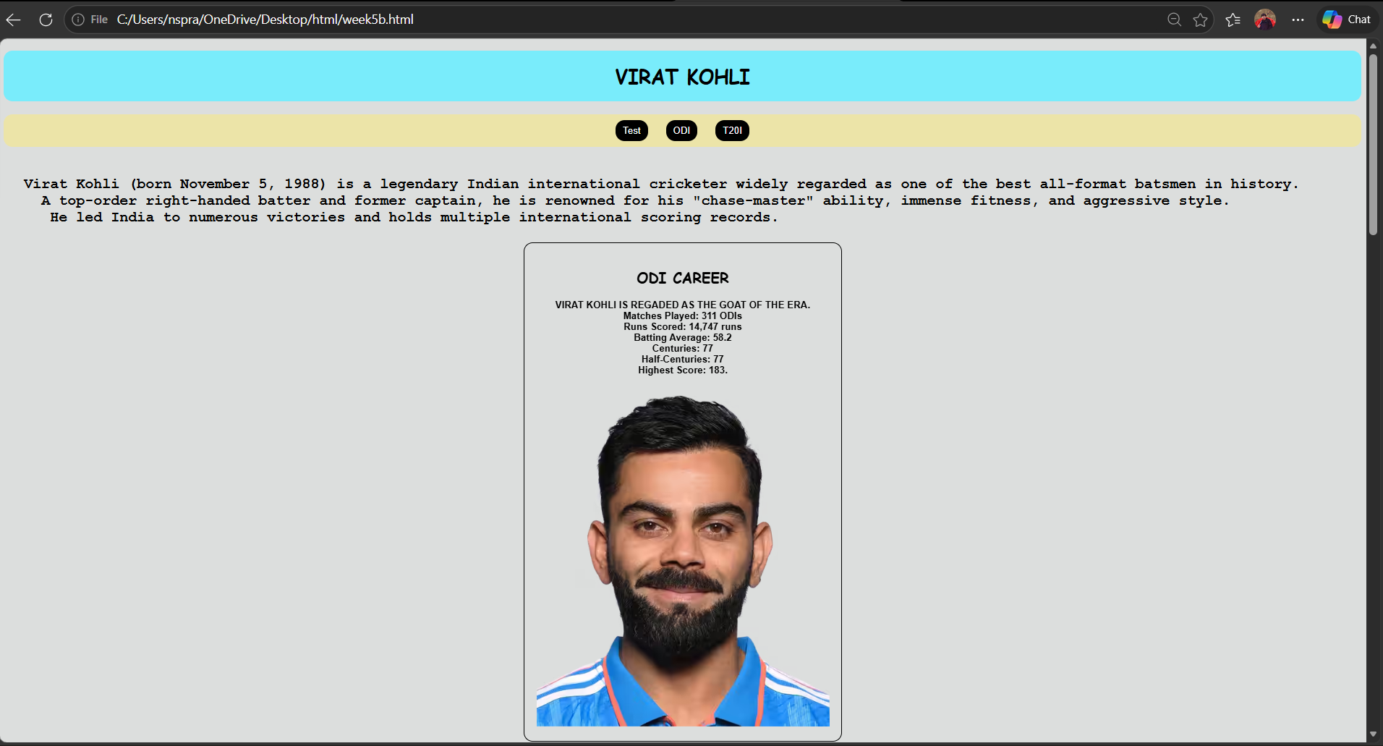

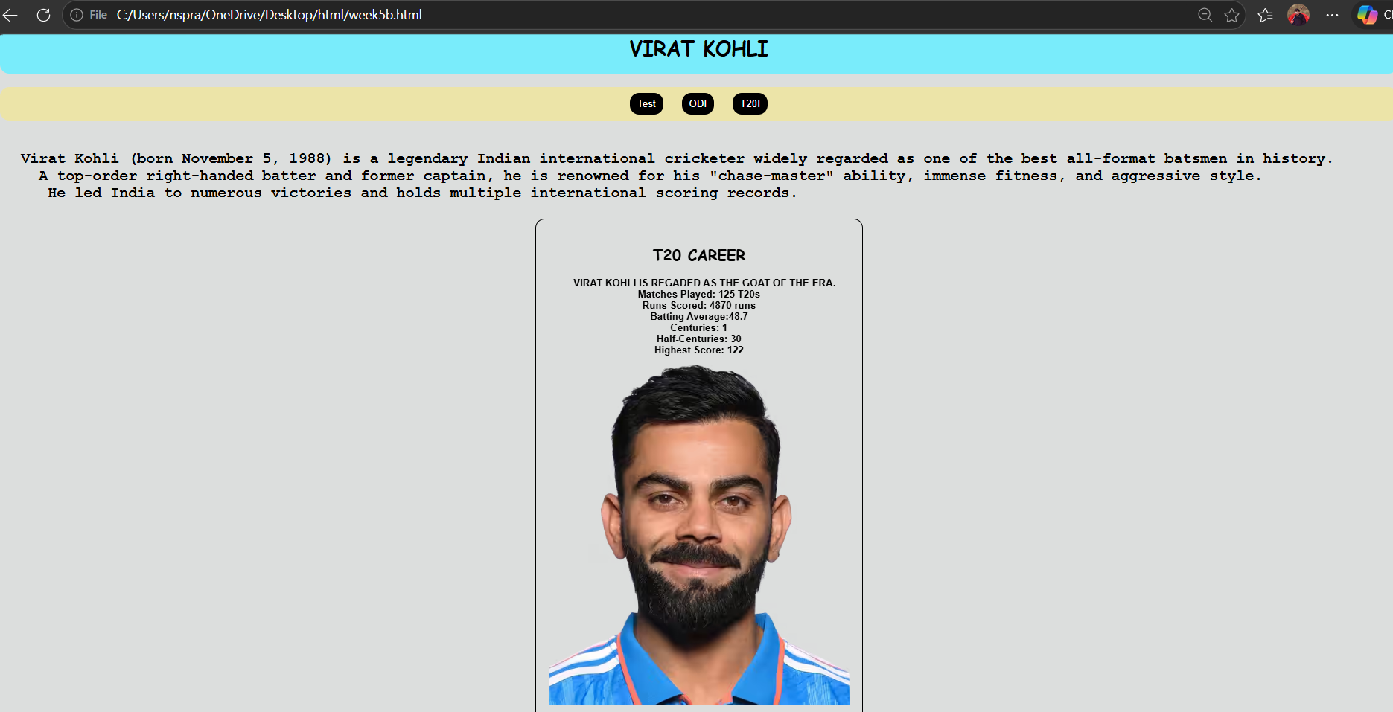

Explanation:
1. <div> = A <div> is an invisible container used to group HTML elements together so you can style them with CSS or manipulate them with JavaScript as a single unit.
2. <button> = we use <button> element for creating button.
3. Class = A class is a reusable identifier used to apply the same CSS styles.
4. Display : flex = Display flex is a CSS property used to easily align, gap, and distribute space among items within a container.
5. Gap = Gap is the external space between multiple items inside a Flex or Grid container.
6. Padding = Padding is the internal space inside an element (between its border and its content).
7. Cursor : pointer = Cursor pointer is a CSS property used to change the mouse icon into a hand with a pointing finger.
8. Margin = Margin is a CSS property used to create empty space around an element.
9. box-shadow: 0 4px 6px rgba(0,0,0,0.1) = box-shadow is used for creating a shadow around a box.
10.Display : inline-block = Display inline-block is a CSS property that blends the best of both worlds: it allows elements to sit side-by-side.
This code is written using internal css. And all the other three codes are combined using <a herf > in the main code.

5.c)Aim: Design amrita login page by showcampus on home page.upon clicking on each campus the details about each campus should be display on the same page use html and css to design a stylish webpage.
<!DOCTYPE html>

<html>

<head>

<title>login webpage</title>

<style>

body{

background-image: url(img.jpg);

background-size: cover;

}

nav{

background:#b2c6d7;

text-align:center;

padding:10px;

}

nav a{color:rgb(140, 154, 233);

margin:12px;

text-decoration:none;

font-weight:bold;

padding:5px;

}
nav a {

text-decoration: none;
}
.heading{

font-size: 35px;

color: white;

background-color: rgb(208, 230, 119);
text-align: center;

padding:12px;

border-radius: 15px;

}

.main-container {

width: 1150px;

height: 50px;

}

.login-box {

float: left;

width: 360px;

background-color: #77b177;

padding: 35px;

color: white;

border-radius: 15px;

opacity: 0.8;

border: 1px solid rgba(255,255,255,0.3);

height: 450px;

}

.login input[type="email"],

.login input[type="password"]{

width:90%;

padding:6px;

margin:6px 0;

}

.button{

border-radius: 15px;

background-color: #501df7;

color: white;

width: 75px;

}

iframe{

flex:1;

margin-left:20px;

height:520px;

border:none;

background:rgb(181, 227, 255);

border-radius:10px;

width: 950px;

opacity: 0.9;

}

</style>

</head>

<body>

<div class="heading">Amrita Vishwa Vidyapeetham</div>

<br>

<nav>

<a href="amaravati.html" target="campus">AMARAVATI</a>

<a href="amritapuri.html" target="campus">AMRITAPURI</a>

<a href="bengaluru.html" target="campus">BENGALURU</a>

<a href="chennai.html" target="campus">CHENNAI</a>

<a href="coimbatore.html" target="campus">COIMBATORE</a>

<a href="kochi.html" target="campus">KOCHI</a>

<a href="mysuru.html" target="campus">MYSURU</a>

</nav>

<div class="login-box">

<h2>Login</h2>

Email<br>

<input type="email"><br>

Password <br>

<input type="password">

<div class="remember">

<input type="checkbox"><label>Save me</label>

</div>

<input type="button" value="Login" class="button" >

<br><br>

<a href=" ">Forgot Password?</a><br>

No account? <a href=" ">Register</a>

</div>

<iframe name="campus" src="amaravati.html"></iframe>

</body>

</html>

AMARAVATI.HTML:
<!DOCTYPE html>

<html>

<body style=" text-align:center;">

<h1 style="color:#a00000;">Amaravati Campus</h1>

<p>

One of the newer additions, this 200-acre campus in Andhra Pradesh is designed as a modern tech-and-business-centric educational center.

</p>

<p>

nirf ranking : 8th for university<br>

Popular Courses: CSE, AI, Data Science<br>

Facilities: Library, Smart Classrooms, Hostel<br>

Focus: Innovation and Research

</p>

<img src="amaravati.jpg" width="450" style="border-radius: 15px;">

</body>

</html>

AMRITAPURI.HTML:
<!DOCTYPE html>

<html>

<body style="text-align:center;">

<h1 style="color:#ff0b0b;">Amritapuri Campus</h1>

<p>

Located near the headquarters of the Mata Amritanandamayi Math, it's famous for blending high-end research with a spiritual, seaside atmosphere.

</p>

<p>

nirf ranking : 8th for university<br>

Popular Courses: Engineering, Arts, Sciences<br>

Facilities: Research Labs, Hostel,Beautiful nature <br>

Focus: Academic Excellence with Values

</p>

<img src="amritapuri.jpg" width="450" style="border-radius: 15px;">

</body>

</html>

BENGABENGALURU.HTML:
<!DOCTYPE html>

<html>

<body style="text-align:center;">

<h1 style="color:#a00000;">Bengaluru Campus</h1>

<p>

Located in India's tech hub, Bengaluru campus offers advanced

engineering programs with strong industry connections.

</p>

<p>

nirf ranking : 8th for university <br>

Popular Courses: Robotics, CSE, ECE<br>

Facilities: Coding Labs, Innovation Centres<br>

Focus: Industry Collaboration

</p>

<img src="bengaluru.jpg" width="450" style="border-radius:15px;">

</body>

</html>

CHENNAI.HTML:
<!DOCTYPE html>

<html>

<body style="text-align:center;">

<h1 style="color:#a00000;">Chennai Campus</h1>

<p>

Chennai campus provides top-quality computing and management education

with modern infrastructure.

</p>

<p>

nirf ranking : 8th for university<br>

Popular Courses: IT, MBA, Electronics<br>

Facilities: Digital Library, Placement Cell<br>

Focus: Career Development

</p>

<img src="chennai.jpg" width="450" style="border-radius:15px;">

</body>

</html>

COIMBATORE.HTML:
<!DOCTYPE html>

<html>

<body style="text-align:center;">

<h1 style="color:#a00000;">Coimbatore Campus</h1>

<p>

The massive 450-acre headquarters known for its top-tier engineering programs and lush, eco-friendly "oasis" setting.

</p>

<p>

nirf ranking : 8th for university<br>

Popular Courses: Mechanical, Civil, CSE<br>

Facilities: Workshops, Labs, Hostel<br>

Focus: Core Engineering Skills

</p>

<img src="coimbatore.jpg" width="450" style="border-radius: 15px;">

</body>

</html>
MYSURU.HTML:
<!DOCTYPE html>

<html>

<body style="text-align:center;">

<h1 style="color:#a00000;">Mysuru Campus</h1>

<p>

Mysuru campus is known for its peaceful environment,

green campus, and quality education.

</p>

<p>

nirf ranking : 8th for university<br>

Popular Courses: Arts, Sciences, Engineering<br>

Facilities: Hostel, Library, Sports Complex<br>

Focus: Calm Learning Atmosphere

</p>

<img src="mysuru.jpg" width="450" style="border-radius:15px;">

</body>

</html>

OUTPUT:
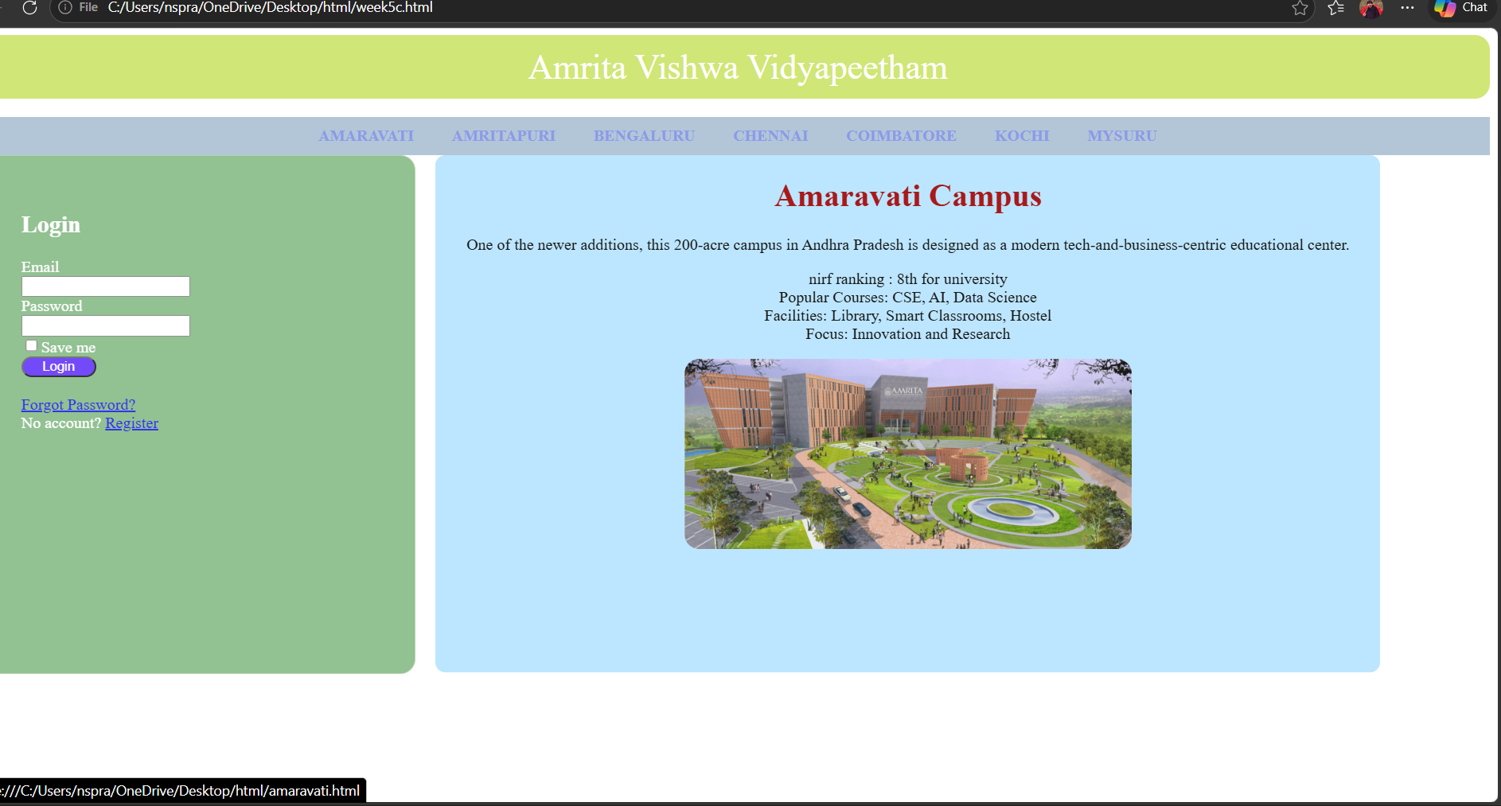
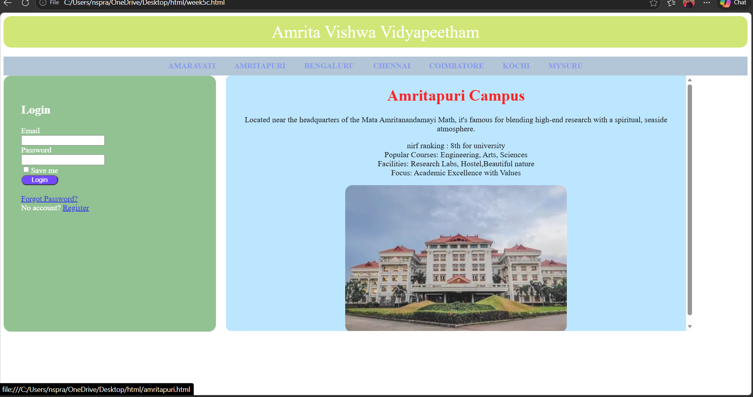

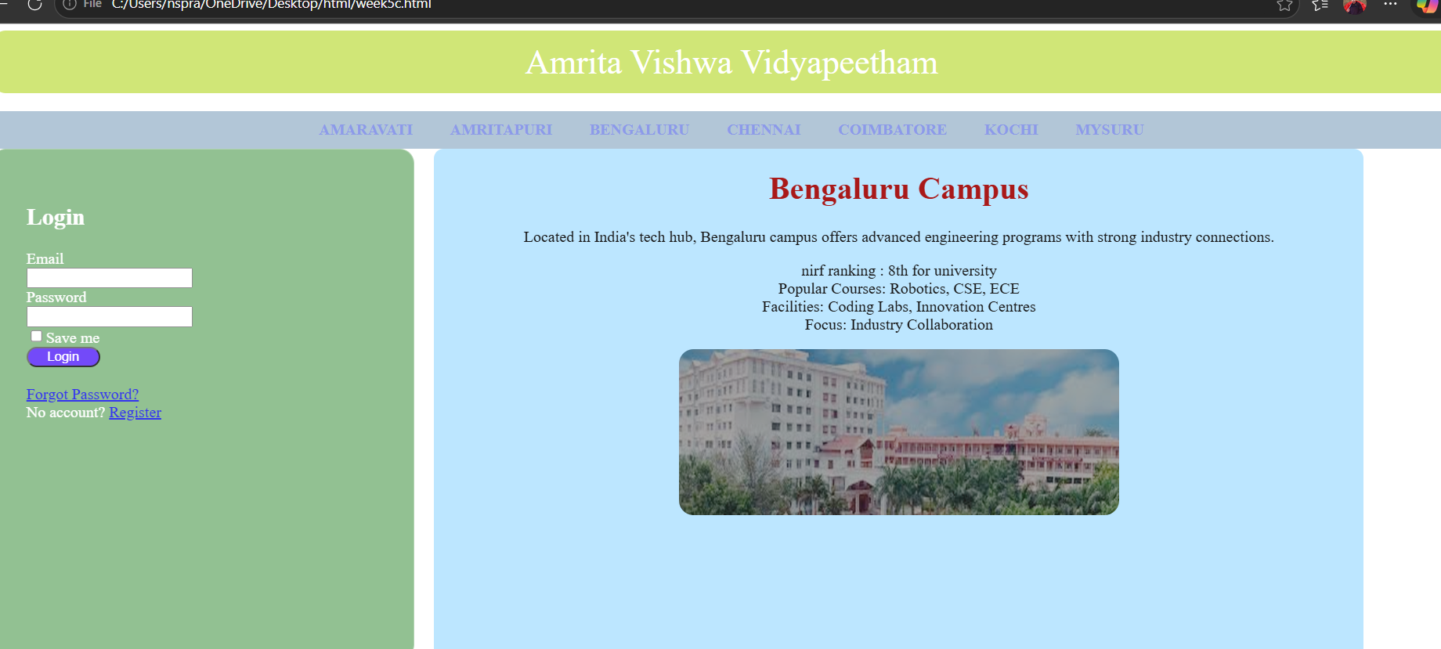

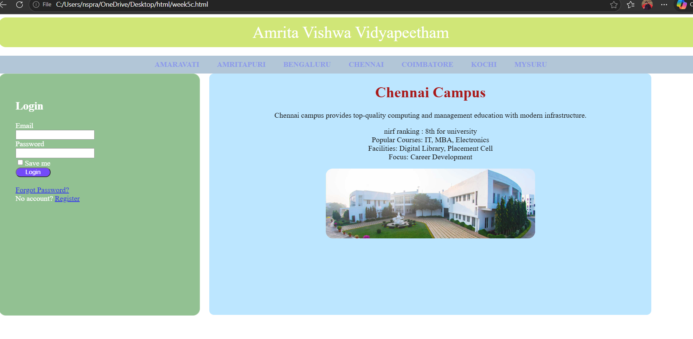

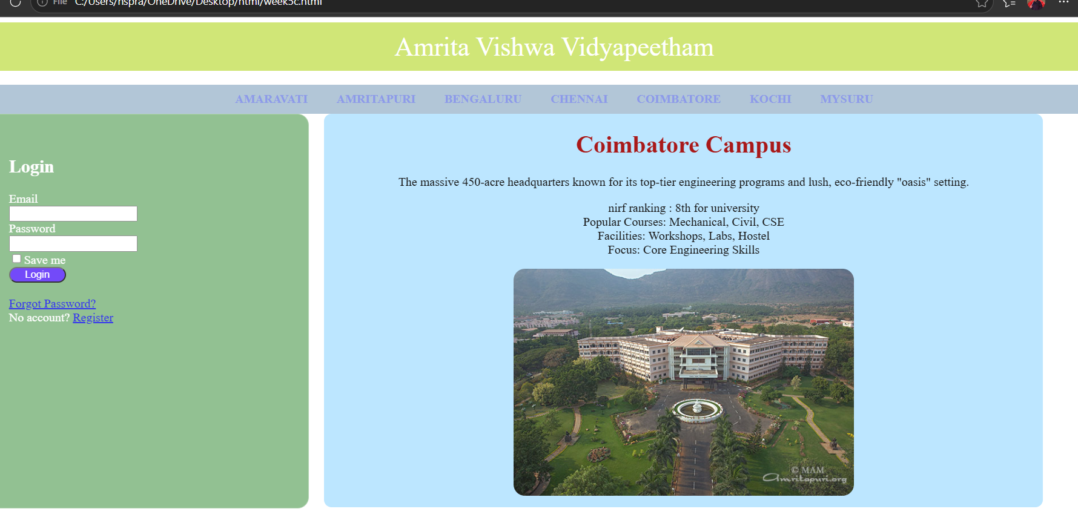
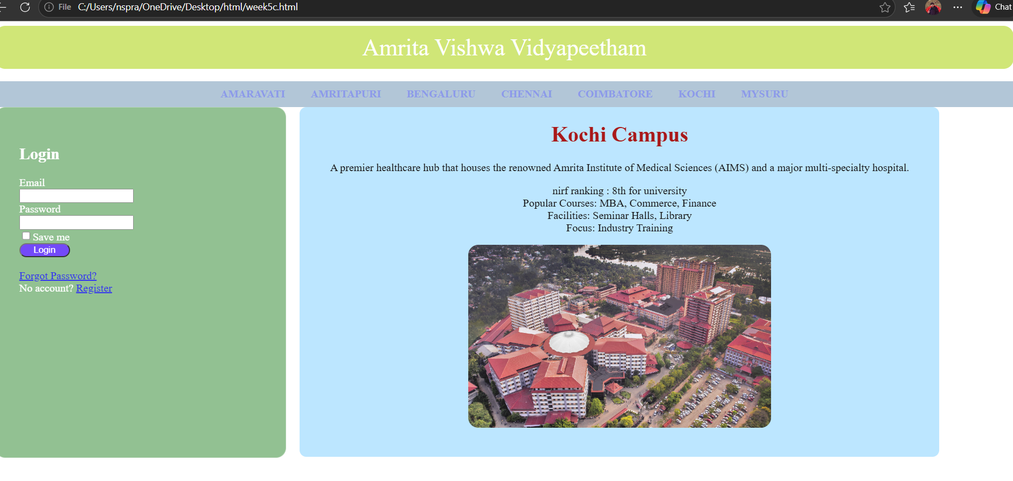

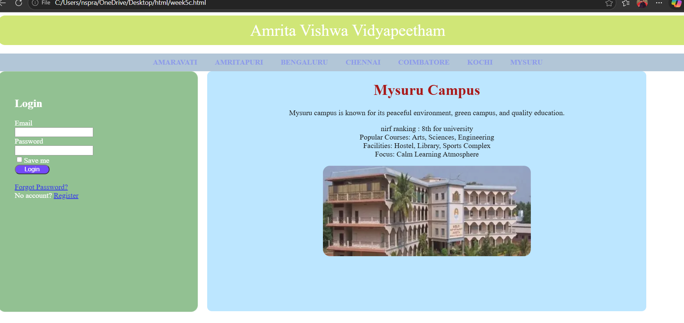

Explanation:
1. <div> = A <div> is an invisible container used to group HTML elements together so you can style them with CSS or manipulate them with JavaScript as a single unit.
2. <button> = we use <button> element for creating button.
3. Class = A class is a reusable identifier used to apply the same CSS styles.
4. Display : flex = Display flex is a CSS property used to easily align, gap, and distribute space among items within a container.
5. Gap = Gap is the external space between multiple items inside a Flex or Grid container.
6. Padding = Padding is the internal space inside an element (between its border and its content).
7. Cursor : pointer = Cursor pointer is a CSS property used to change the mouse icon into a hand with a pointing finger.
8. Margin = Margin is a CSS property used to create empty space around an element.
9. box-shadow: 0 4px 6px rgba(0,0,0,0.1) = box-shadow is used for creating a shadow around a box.
10.Display : inline-block = Display inline-block is a CSS property that blends the best of both worlds: it allows elements to sit side-by-side.
This code is written using internal css. And all the other three codes are combined using <a herf > in the main code.

WEEK-6
AIM :
6) : Design a responsive e-commerce application using the grid layout. This application should contain different categories of products such as electronics, clothing, home-appliances, books.

CODE:
MAIN.HTML1:

<!DOCTYPE html>
<html>
<head>
<title>E-commerce Site</title>
<style>
body {
margin: 0;
background-color: aliceblue;
font-family: sans-serif;
}

.container {
display: grid;
min-height: 100vh;
grid-template-rows: auto auto 1fr auto;
grid-template-columns: 200px 1fr;
grid-template-areas:
"header header"
"sale sale"
"sidebar products"
"footer footer";

}

.header {
grid-area: header;
background-color: blanchedalmond;
text-align: center;
padding: 10px;
margin-top: 0px;
border-radius: 8px;
}

.sale {
grid-area: sale;
background-color: tomato;
opacity: 0.9;
color: white;
border-radius: 8px;
text-align: center;
padding: 10px;
font-size: 19px;
font-weight: bold;
}

.sidebar {
grid-area: sidebar;
background-color: #e3f2fd;
padding: 20px;
border-radius: 9px;
opacity: 0.9;
border-right: 1px solid #ccc;
}
.frame {
grid-area: products;
width: 100%;
height: 100%;
border: none;
}

.sidebar a {
display: block;
color: black;
text-decoration: none;
padding: 10px 0;
border-bottom: 1px solid #d1e9ff;
}

.sidebar a:hover {
color: blue;
}

.footer {
grid-area: footer;
background-color: black;
color: white;
text-align: center;
padding: 2px;
}
</style>
</head>
<body>

<div class="container">
<div class="header">
<h1>Online store</h1>
</div>

<div class="sale">
<p>BIG SALE! 50% OFF!!</p>
</div>

<div class="sidebar">
<h3>Categories</h3>
<hr>
<a href="electronics.html" target="frame">Electronics</a>
<a href="clothes.html" target="frame">Clothes</a>
<a href="accessories.html" target="frame">Accessories</a>
</div>

<iframe class="frame" name="frame" src="electronics.html"></iframe>

<footer class="footer">
<p>2026 E-commerce Store Concept</p>
</footer>
</div>

</body>
</html>

ACCESORIES,HTML:

<!DOCTYPE html>
<html>
<head>
<title>Electronics</title>
<style>
body {
margin: 0;
background-color: aliceblue;
font-family: sans-serif;
}

.products {
grid-area: products;
display: grid;
grid-template-columns: repeat(2, 1fr);
gap: 20px;
padding: 20px;
}

.product-card {
background: white;
border: 1px solid #ddd;
padding: 20px;
text-align: center;
border-radius: 8px;
}
.p{
text-align: center;
background-color: tomato;
align-items: center;
}
img{
width: 120px;
height: auto;
border-radius: 8px;
}

.button {
background-color: blue;
color: white;
border: none;
padding: 10px 20px;
cursor: pointer;
border-radius: 50px;
margin-top: 10px;
}

.button:hover {
background-color: #7094ff;
}
</style>
</head>
<body>
<div class="products">
<div class="product-card">
<img src=""C:\Users\nspra\Downloads\s26watches.jpg.jpeg"" alt="Samsung Galaxy Watch 6">
<h3>Samsung Galaxy Watch 6</h3>
<p>$169</p>
<button class="button">Add to Cart</button>
</div>
<div class="product-card">
<img src=""C:\Users\nspra\Downloads\earpodes.jpg.jpeg"" >
<h3>Samsung Galaxy Buds 4</h3>
<p>$249</p>
<button class="button">Add to Cart</button>
</div>
<div class="product-card">
<img src=""C:\Users\nspra\Downloads\ring.jpg.jpeg"">
<h3>Samsung Galaxy ring </h3>
<p>$459</p>
<button class="button">Add to Cart</button>
</div>
<div class="product-card">
<img src=""C:\Users\nspra\Downloads\s26backcase.jpg.jpeg"">
<h3>Samsung S26 case </h3>
<p>$59</p>
<button class="button">Add to Cart</button>
</div>
</div>
</body>

CLOTHES.HTML:
<!DOCTYPE html>
<html>
<head>
<title>Clothes</title>
<style>
body {
margin: 0;
background-color: aliceblue;
font-family: sans-serif;
}

.products {
grid-area: products;
display: grid;
grid-template-columns: repeat(2, 1fr);
gap: 20px;
padding: 20px;
}

.product-card {
background: white;
border: 1px solid #ddd;
padding: 20px;
text-align: center;
border-radius: 8px;
}
img{
width: 120px;
height: auto;
border-radius: 8px;
}
.p{
text-align: center;
background-color: tomato;
align-items: center;
}

.button {
background-color: blue;
color: white;
border: none;
padding: 10px 20px;
cursor: pointer;
border-radius: 50px;
margin-top: 10px;
}

.button:hover {
background-color: #7094ff;
}
</style>
</head>
<body>
<div class="products">
<div class="product-card">
<img src="C:\Users\nspra\Downloads\whitepolotshirt,jpg.jpeg">
<h3>USPA off-white shirt</h3>
<p>$39</p>
<p>Size: S , M , XL , XXL</p>
<button class="button">Add to Cart</button>
</div>
<div class="product-card">
<img src="C:\Users\nspra\Downloads\blueshirt.jpg.jpeg">
<h3>USPA blue Shirt</h3>
<p>$59</p>
<p>Size: S , M , L , XL</p>
<button class="button">Add to Cart</button>
</div>
<div class="product-card">
<img src="C:\Users\nspra\Downloads\blackpant.jpg.jpeg">
<h3>USPA black pants</h3>
<p>$49</p>
<p>Size: 28 , 30 , 32 , 34</p>
<button class="button">Add to Cart</button>
</div>
<div class="product-card">
<img src="C:\Users\nspra\Downloads\greenpant.jpg.jpeg">
<h3>USPA Green pants</h3>
<p>$52</p>
<p>Size: 28 , 30 , 32 , 34</p>
<button class="button">Add to Cart</button>
</div>
</div>
</body>
</html>

ELECTRONIC.HTML
<!DOCTYPE html>
<html>
<head>
<title>Electronics</title>
<style>
body {
margin: 0;
background-color: aliceblue;
font-family: sans-serif;
}

.products {
grid-area: products;
display: grid;
grid-template-columns: repeat(2, 1fr);
gap: 10px;
padding: 20px;
}

.product-card {
background: white;
border: 1px solid #ddd;
padding: 20px;
text-align: center;
border-radius: 8px;
height: auto;
width: 600px;
width: 100%;
}
.p{
text-align: center;
background-color: tomato;
align-items: center;
}
img{
width: 120px;
height: auto;
border-radius: 8px;
}

.button {
background-color: blue;
color: white;
border: none;
padding: 10px 20px;
cursor: pointer;
border-radius: 50px;
margin-top: 10px;
}

.button:hover {
background-color: #7094ff;
}
</style>
</head>
<body>
<div class="products">
<div class="product-card">

<img src="C:\Users\nspra\Downloads\iphone.jpg.jpeg">
<h3>Iphone 17</h3>
<p>$899</p>
<p>12GB RAM | 256GB Storage</p>
<button class="button">Add to Cart</button>
</div>
<div class="product-card">
<img src="C:\Users\nspra\Downloads\s26.jpg.jpeg">
<h3>Samsung Galaxy S26</h3>
<p>$1199</p>
<p>12GB RAM | 512GB Storage</p>
<button class="button">Add to Cart</button>
</div>
<div class="product-card">
<img src="C:\Users\nspra\Downloads\delllaptop.jpg.jpeg">
<h3>Dell G15</h3>
<p>$799</p>
<p>16GB RAM | 1024GB Storage</p>
<button class="button">Add to Cart</button>
</div>
<div class="product-card">
<img src="C:\Users\nspra\Downloads\hpvictus.jpg.jpeg">
<h3>HP victus</h3>
<p>$749</p>
<p>16GB RAM | 512GB Storage</p>
<button class="button">Add to Cart</button>
</div>
</div>
</body>
OUTPUT:
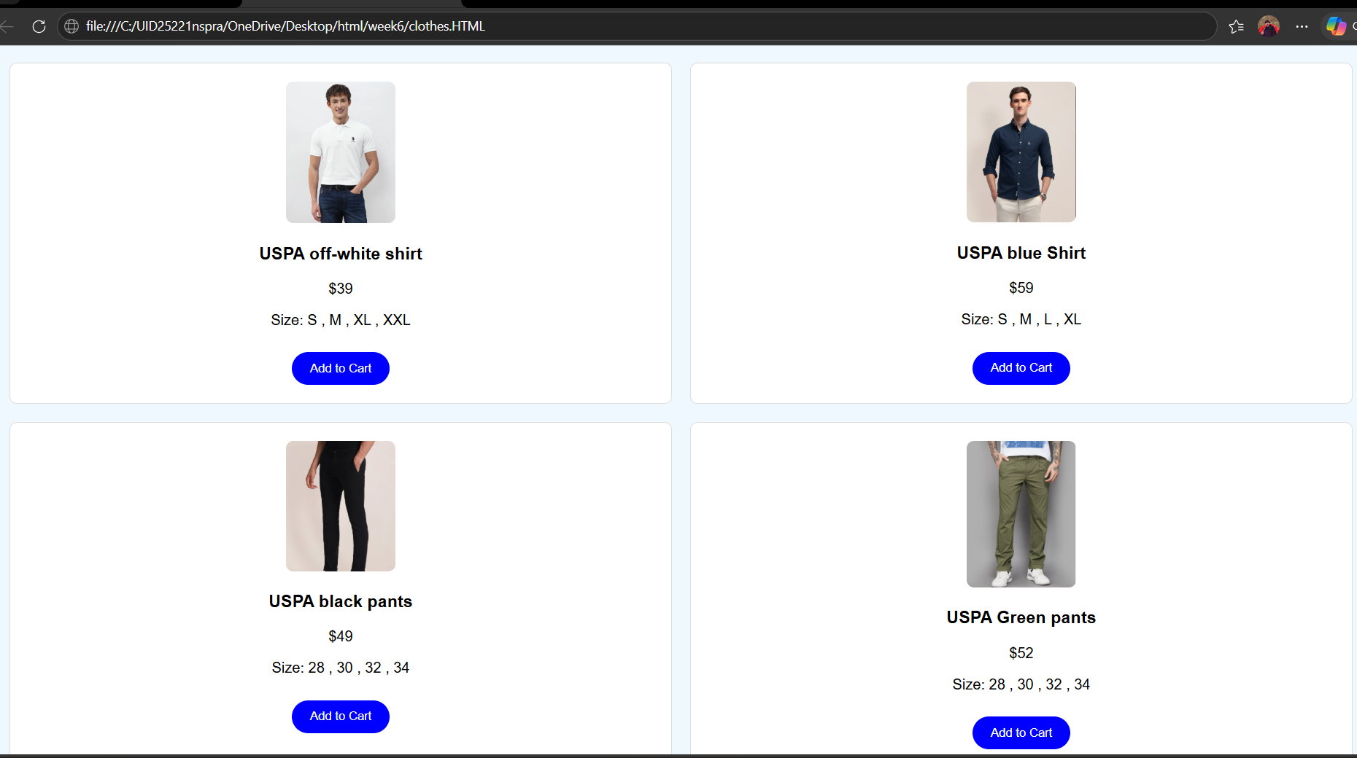
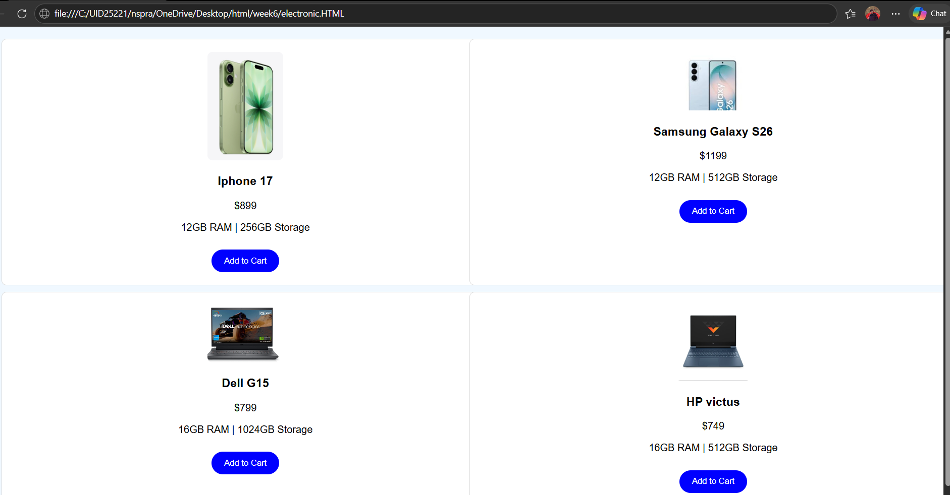
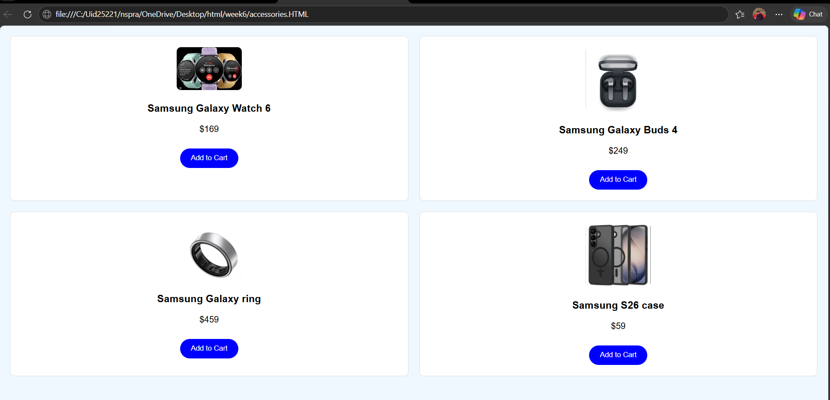
EXPLANTION:
Explanation:
<DOCTYPE html> : the <!DOCTYPE html> element tells the web browser that this an HTML document
or this is the latest version of HTML
<html> : the <html> element is the root element of an HTML web page
<head> : the <head> element will contain meta data about the HTML web page
<title> : the <title> element specifies a title for the HTML Page
<body> : the <body> element contains all visible content all visible content like text , image , links ,
tables , etc
<h> : we used <h> element for heading
<p> : we used <p> element for the paragraph
<div>:we use <div> element for encapsulating the the divisions and easy to modify and
<button>: we use <button> element for button
<img>: we use <img> tag for displaying the image
We used layout in this program and its attributes like grid-template-rows, grid-template-coloums,
grid-template-area to define the items space for the grid layout by dividing page into separate sections
and use div tag make into small separate blocks

WEEK-7
7.A) Aim: create a GitHub account and create a repository in it and push all the week 6 code files in it.
PROCEDURE:
Step 1: browse for GitHub and enter it.
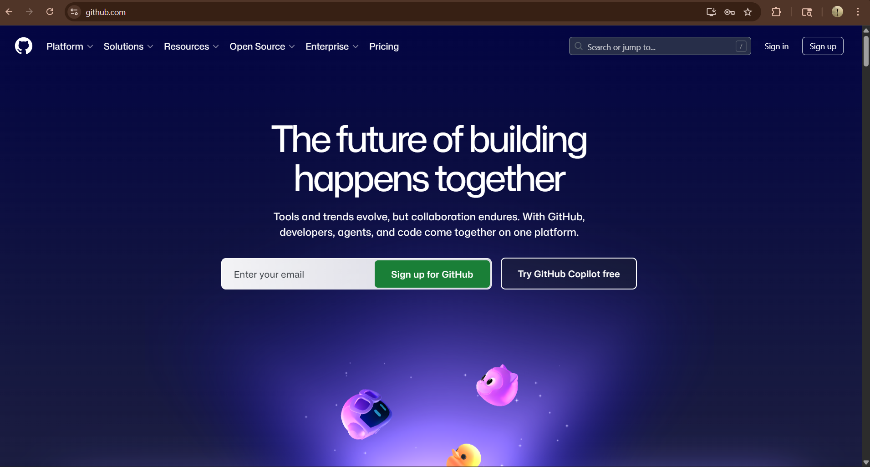
Step 2:login to GitHub account.
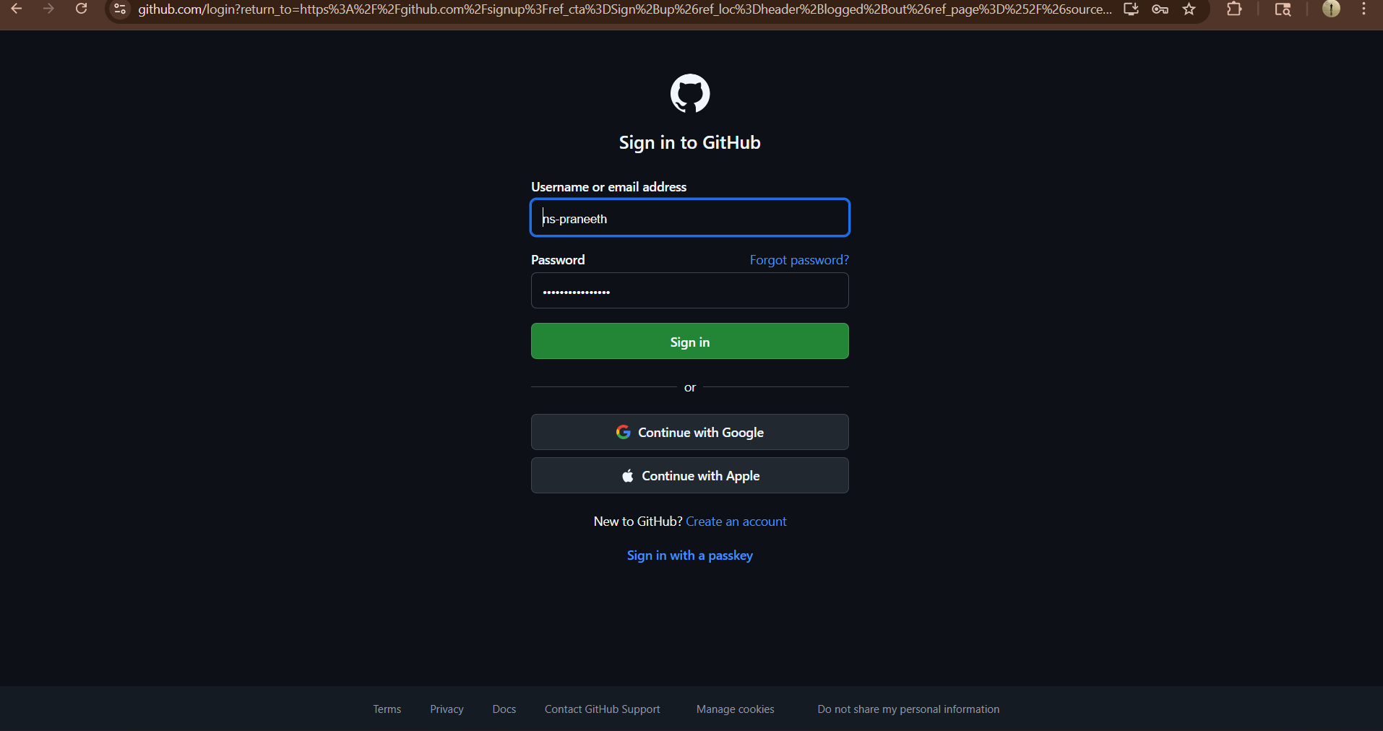
Step 3:create a repository after login by clicking new
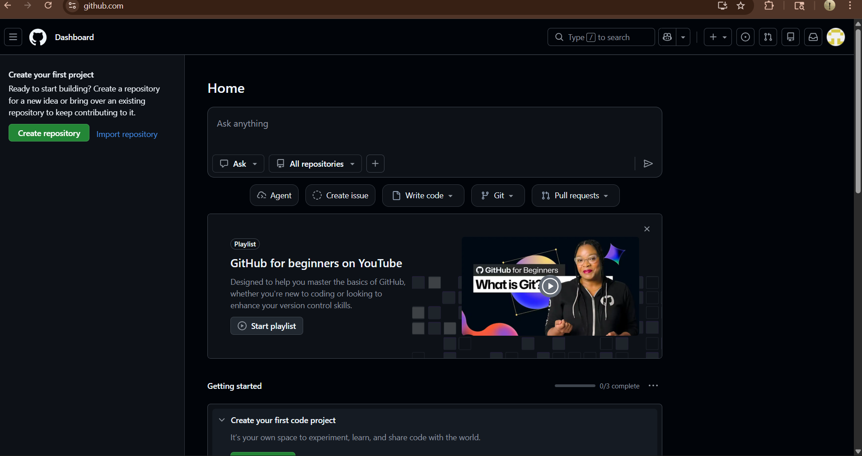

Step 4:specify the repository specifications.
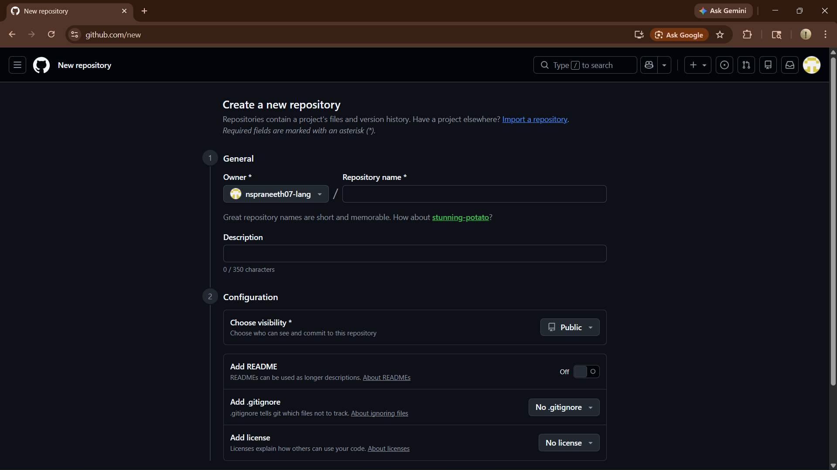

Step 5:download GitHub desktop and Lauch it .
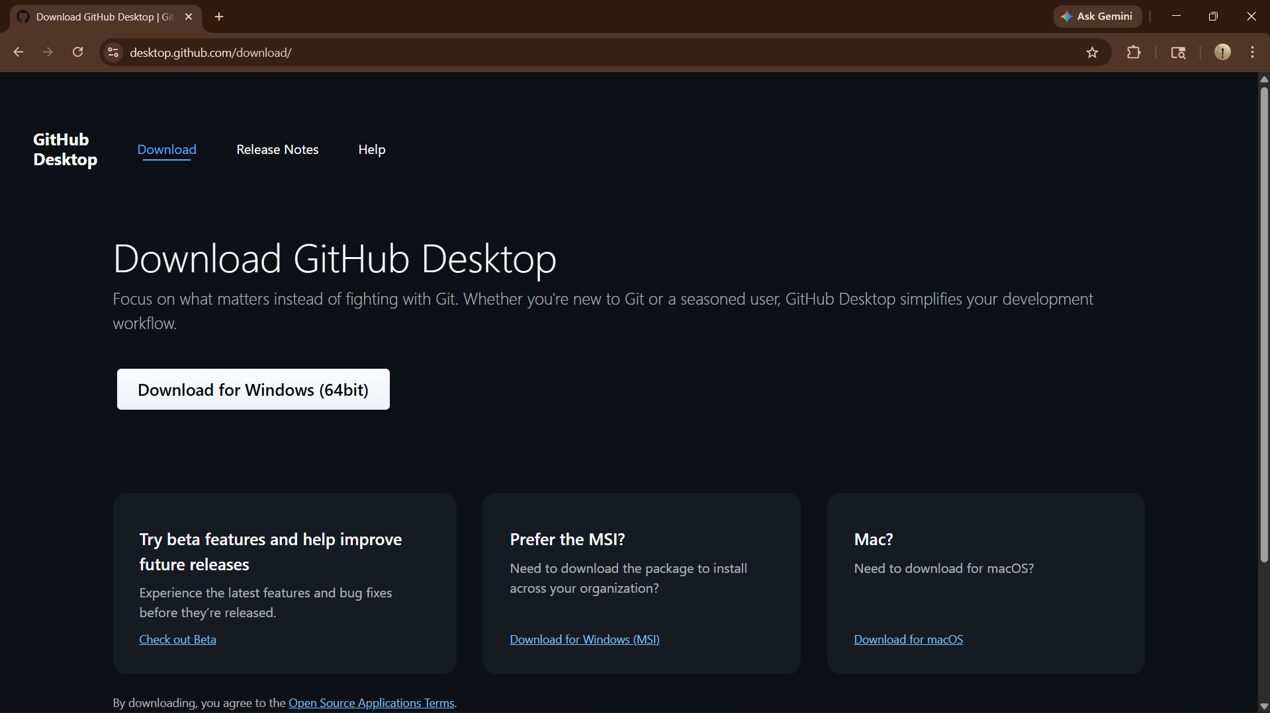

Step 7:add the vs code file to the GitHub desktop.
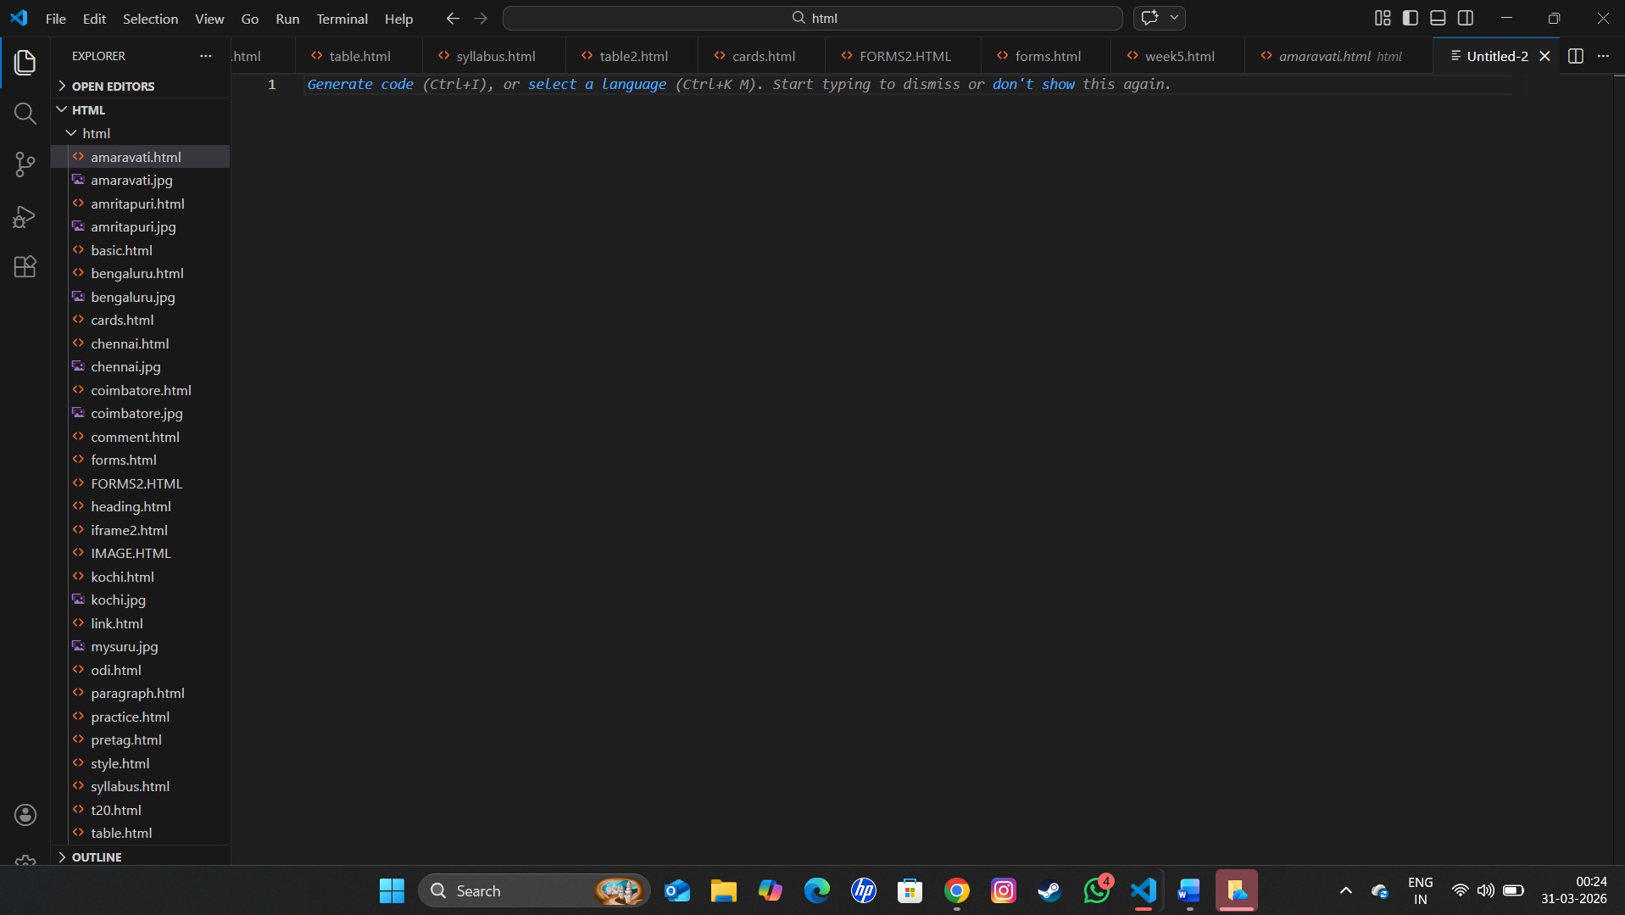

Step 8:add commit to it and the files to repository and sync the changes . it automatically
pushes the files .
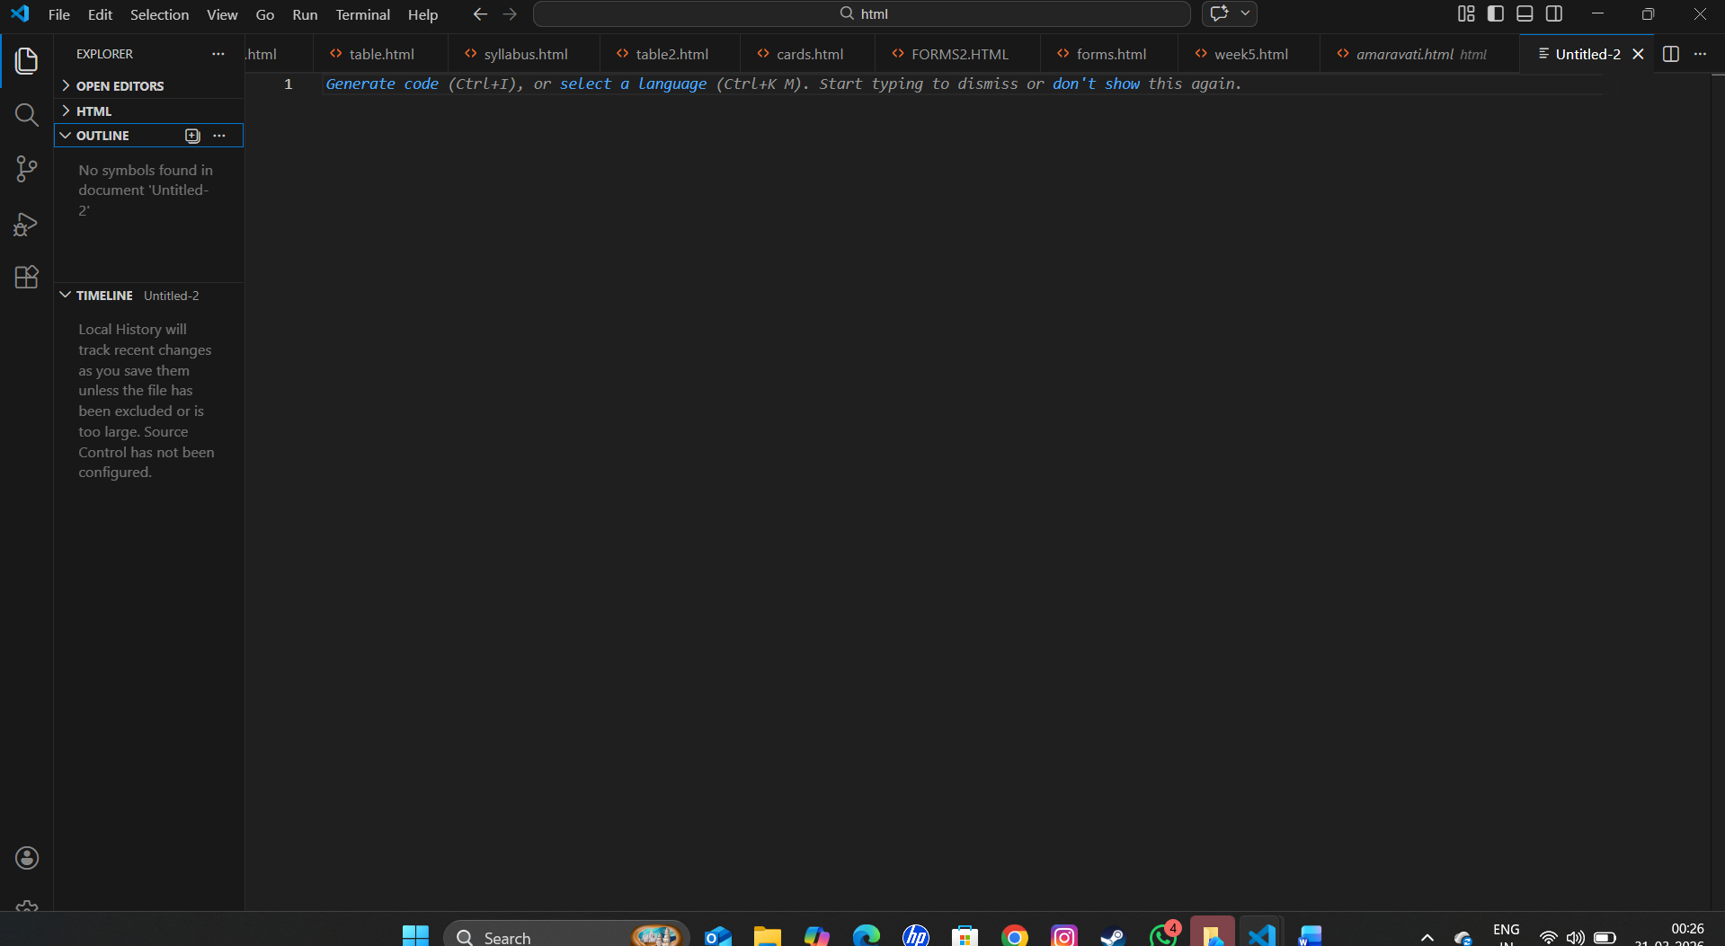
Step 9:now go to browser and check it . it will show all the new added files in the repository:
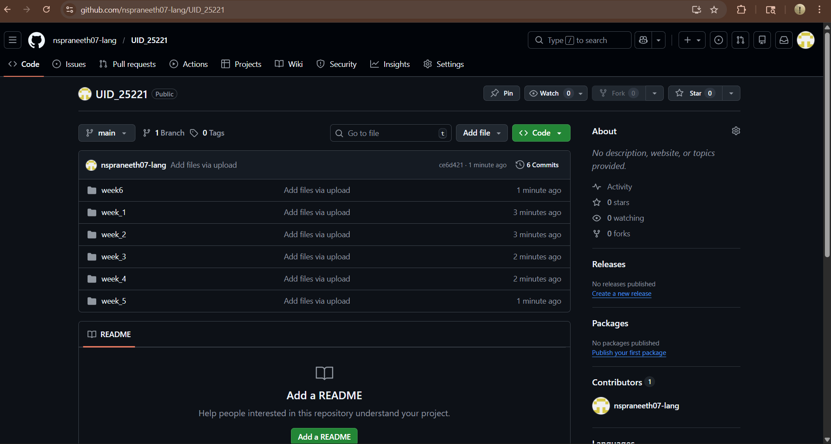

My repository link for the uid all week’s work:
https://github.com/nspraneeth07-lang/UID_25221.git

WEEK-8
8.A) Aim: create a web page that displays a square that continuously rotates 360 using css animation Program

Code:

Name = Praneeth , Roll no = 25221 , Section-C

<!DOCTYPE html>

<html>

<head>
<title>Continuous Rotating Square</title>

<style>

body {

display: flex;

flex-direction: column;

align-items: center;

margin: 0;

}

.rotating-square {

width: 150px;

height: 150px;

background-color: #c3e050;

border-radius: 15px;

box-shadow: 0 4px 15px rgba(0,0,0,0.2);

animation: spin 4s linear infinite;

}

@keyframes spin {
from {

transform: rotate(0deg);

}

to {

transform: rotate(360deg);

}

}

</style>

</head>

<body>

<h1>Continuous Rotating Square</h1>

<div class="rotating-square"></div>

</body>

</html>

OUTPUT :
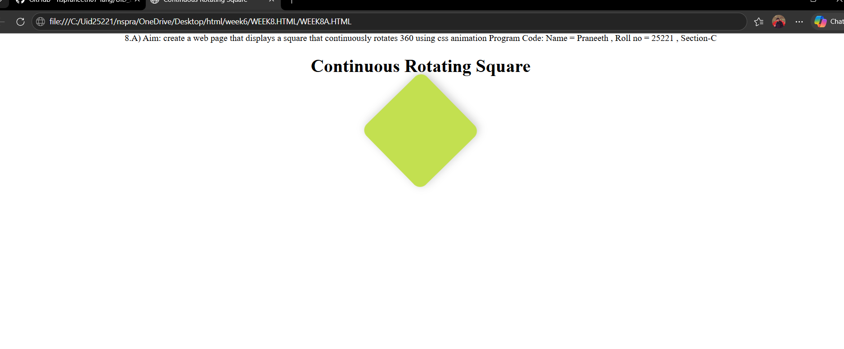

Explanation:

flex-direction: column = is used to change the orientation of your layout from a horizontal row to a vertical column.

display: flex = It is used to easily align the items and distribute space within the container.

Align-items:centre = It is used to horizontally center the content because of the flex direction.

<div> = A <div> is an invisible container used to group HTML elements together so you can style them with CSS.

@keyframes = a keyframe tells the computer exactly how an element should look at a specific point in time.

Animation = Animation is shorthand property for name , duration , timing function , delay , iteration count , direction , fill mode , play state.

8.B)Aim: To create a ball that moves up and down continuously using css
Animations.

Name = Praneeth , Roll no = 25221 , Section-C
<!DOCTYPE html>
<html>
<head>
<style>
body {
display: flex;
flex-direction: column;
align-items: center;
margin: 0;
}
h1{
text-align: center;
}
.ball {
width: 70px;
height: 70px;
background: rgb(236, 224, 5);
border-radius: 100%;
animation: updown 3s linear infinite;
}
@keyframes updown {
0% { transform: translateY(550px); }
50% { transform: translateY(-50px); }
100% { transform: translateY(550px); }
}
</style>
</head>
<body>
<h1>A ball that moves Up and Down continuously</h1><br>
<div class="ball"></div>
</body>
</html>

OUTPUT :
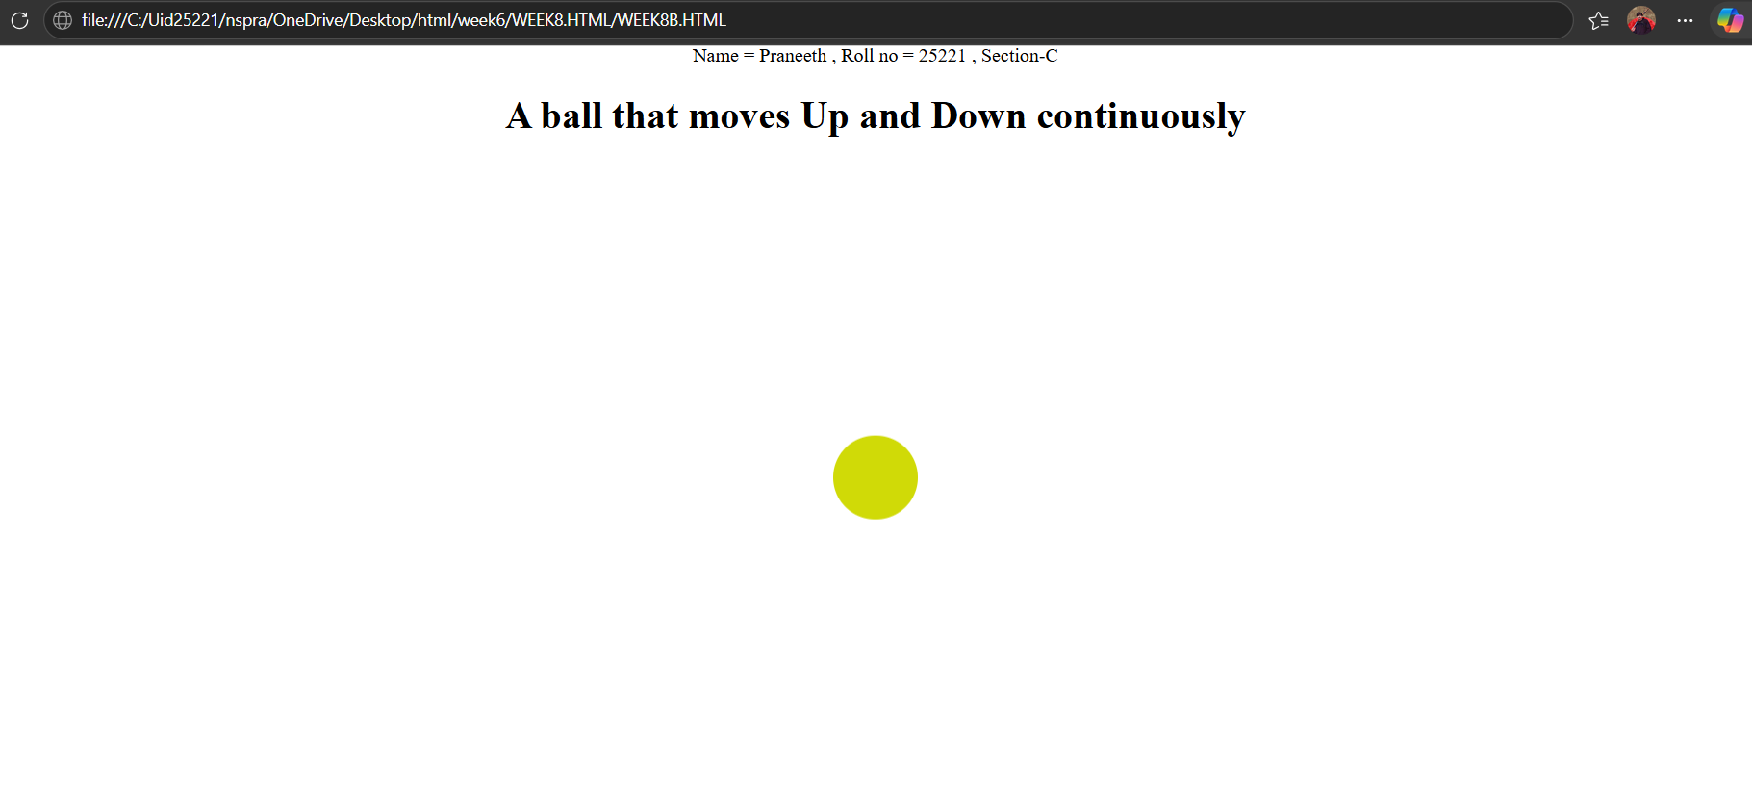
Explanation :
1.flex-direction: column = is used to change the orientation of your layout from a horizontal row to a vertical column.
2.display: flex = It is used to easily align the items and distribute space within the container.
3.Align-items:centre = It is used to horizontally center the content because of the flex direction.
4.<div> = A <div> is an invisible container used to group HTML elements together so you can style them with CSS.
5. @keyframes = a keyframe tells the computer exactly how an element should look at a specific point in time.
6. Animation = Animation is shorthand property for name , duration , timing function , delay , iteration count , direction , fill mode , play state.
7. We denote percentages to tell at a particular time which work should be happen.
The transform: translateY(___px); property is a CSS tool used to move an element vertically along the Y-axis
AIM :
C)Aim :create a circle that moves horizontally and rotates At the same time
<!DOCTYPE html>
<html lang="en">
<head>
<title>Moving Rotating Circle</title>
<style>
body {
margin: 0;
height: 100vh;
display: flex;
flex-direction: column;
align-items: center;
justify-content: flex-start;
background: #2f3e46;
overflow: hidden;
}
h1 {
margin-top: 20px;
color: #ffffff;
}
.circle {
width: 80px;
height: 80px;
background: #ea0606;
border-radius: 50%;
margin-top: 120px;
animation: moveRotate 3s linear infinite;
}
@keyframes moveRotate {
0% {
transform: translateX(-150px) rotate(0deg);
}
50% {
transform: translateX(150px) rotate(180deg);
}
100% {
transform: translateX(-150px) rotate(360deg);
}
}
</style>
</head>
<body>
<h1>Moving Rotating Circle</h1>

<div class="circle"></div>
</body>
</html>

OUTPUT :

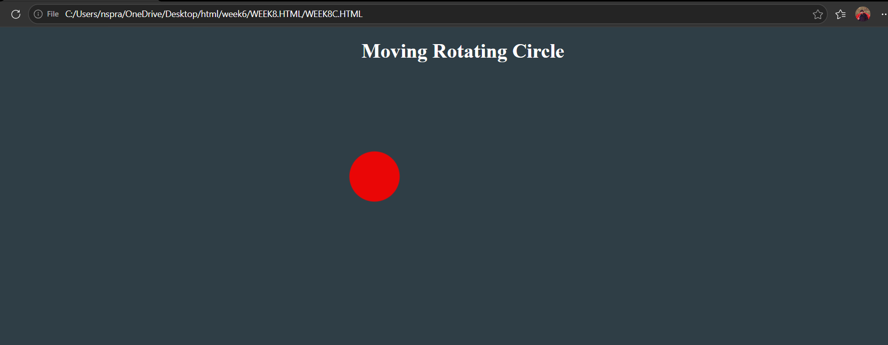 Explanation :
1.flex-direction: column = is used to change the orientation of your layout from a horizontal row to a vertical column.
2.display: flex = It is used to easily align the items and distribute space within the container.
3.Align-items:centre = It is used to horizontally center the content because of the flex direction.
4.<div> = A <div> is an invisible container used to group HTML elements together so you can style them with CSS.
5. @keyframes = a keyframe tells the computer exactly how an element should look at a specific point in time.
6. Animation = Animation is shorthand property for name , duration , timing function , delay , iteration count , direction , fill mode , play state.
7. We denote percentages to tell at a particular time which work should be happen.
The transform: translateY(___px); property is a CSS tool used to move an element vertically along the Y-axis.

WEEK-9
9.A)Aim: Week 9:Create a webpage using html,css,js based on the give conditions, create a button for each program , based on the button, clicked the corresponding program has to be executed and should display the logics for each button includes finding an even or odd number , prime or not , factorial of a number , Armstrong or not use appropriate design to display the output.
CODE:
!DOCTYPE html>
<html>
<head>
<title>value check</title>
<style>
body {
margin: 0;
font-family:'Times New Roman', Times, serif;
background: #27363d;
display: flex;
justify-content: center;
align-items: center;
min-height: 80vh;
}
.container {
background: white;
border-radius: 14px;
box-shadow: 0 4px 20px rgba(52, 37, 37, 0.3);
padding: 50px;
width: 380px;
text-align: center;
}
h2 {
margin-bottom: 20px;
color: #333;
}
input {
width: 100%;
padding: 10px;
font-size: 16px;
border: 2px solid #c4686814;
border-radius: 8px;
margin-bottom: 20px;
box-sizing: border-box;
text-align: center;

}
input:focus {
outline: none;
border-color: #4a90e2;
}
.buttons {
display: grid;
grid-template-columns: 1fr 1fr;
gap: 12px;
margin-bottom: 24px;
}
button {
padding: 12px;
font-size: 15px;
border: none;
border-radius: 8px;
cursor: pointer;
color: white;
font-weight: bold;
background: #4a90e2;
transition: opacity 0.2s;
}
button:hover { opacity: 0.85; }
.output {
background: #f0f4f8;

padding: 20px;
border-radius: 8px;
min-height: 60px;
color: #333;
font-size: 16px;
}
</style>
</head>
<body>

<div class="container">
<h2>Logic Programs</h2>
<input type="number" id="numInput" placeholder="Enter a number" />
<div class="buttons">
<button onclick="checkEvenOdd()">Even / Odd</button>
<button onclick="checkPrime()">Prime / Not</button>

<button onclick="calcFactorial()">Factorial</button>
<button onclick="checkArmstrong()">Armstrong</button>
</div>
<div class="output" id="output">Result will appear here</div>
</div>
<script>
function getInput() {
const val = document.getElementById('numInput').value.trim();
if (val === '' || isNaN(val)) {
document.getElementById('output').textContent = 'Please enter a valid number.';
return null;
}
return parseInt(val);
}
function setOutput(text) {
document.getElementById('output').textContent = text;
}
function checkEvenOdd() {
const n = getInput();
if (n === null) return;
setOutput(n + ' is ' + (n % 2 === 0 ? 'Even' : 'Odd'));
}
function checkPrime() {
const n = getInput();
if (n === null) return;
if (n < 2) { setOutput(n + ' is Not Prime'); return; }
for (let i = 2; i <= Math.sqrt(n); i++) {
if (n % i === 0) { setOutput(n + ' is Not Prime'); return; }
}
setOutput(n + ' is Prime');
}
function calcFactorial() {
const n = getInput();
if (n === null) return;
if (n < 0) { setOutput('Factorial not defined for negative numbers');
return; }
let result = 1;
for (let i = 2; i <= n; i++) result *= i;
setOutput(n + '! = ' + result);
}
function checkArmstrong() {

const n = getInput();
if (n === null) return;
const digits = String(n).split('');
const power = digits.length;
const sum = digits.reduce((acc, d) => acc + Math.pow(Number(d),
power), 0);
setOutput(n + (sum === n ? ' is an Armstrong number' : ' is Not an Armstrong number'));
}
</script>
</body>
</html>

OUTPUT:
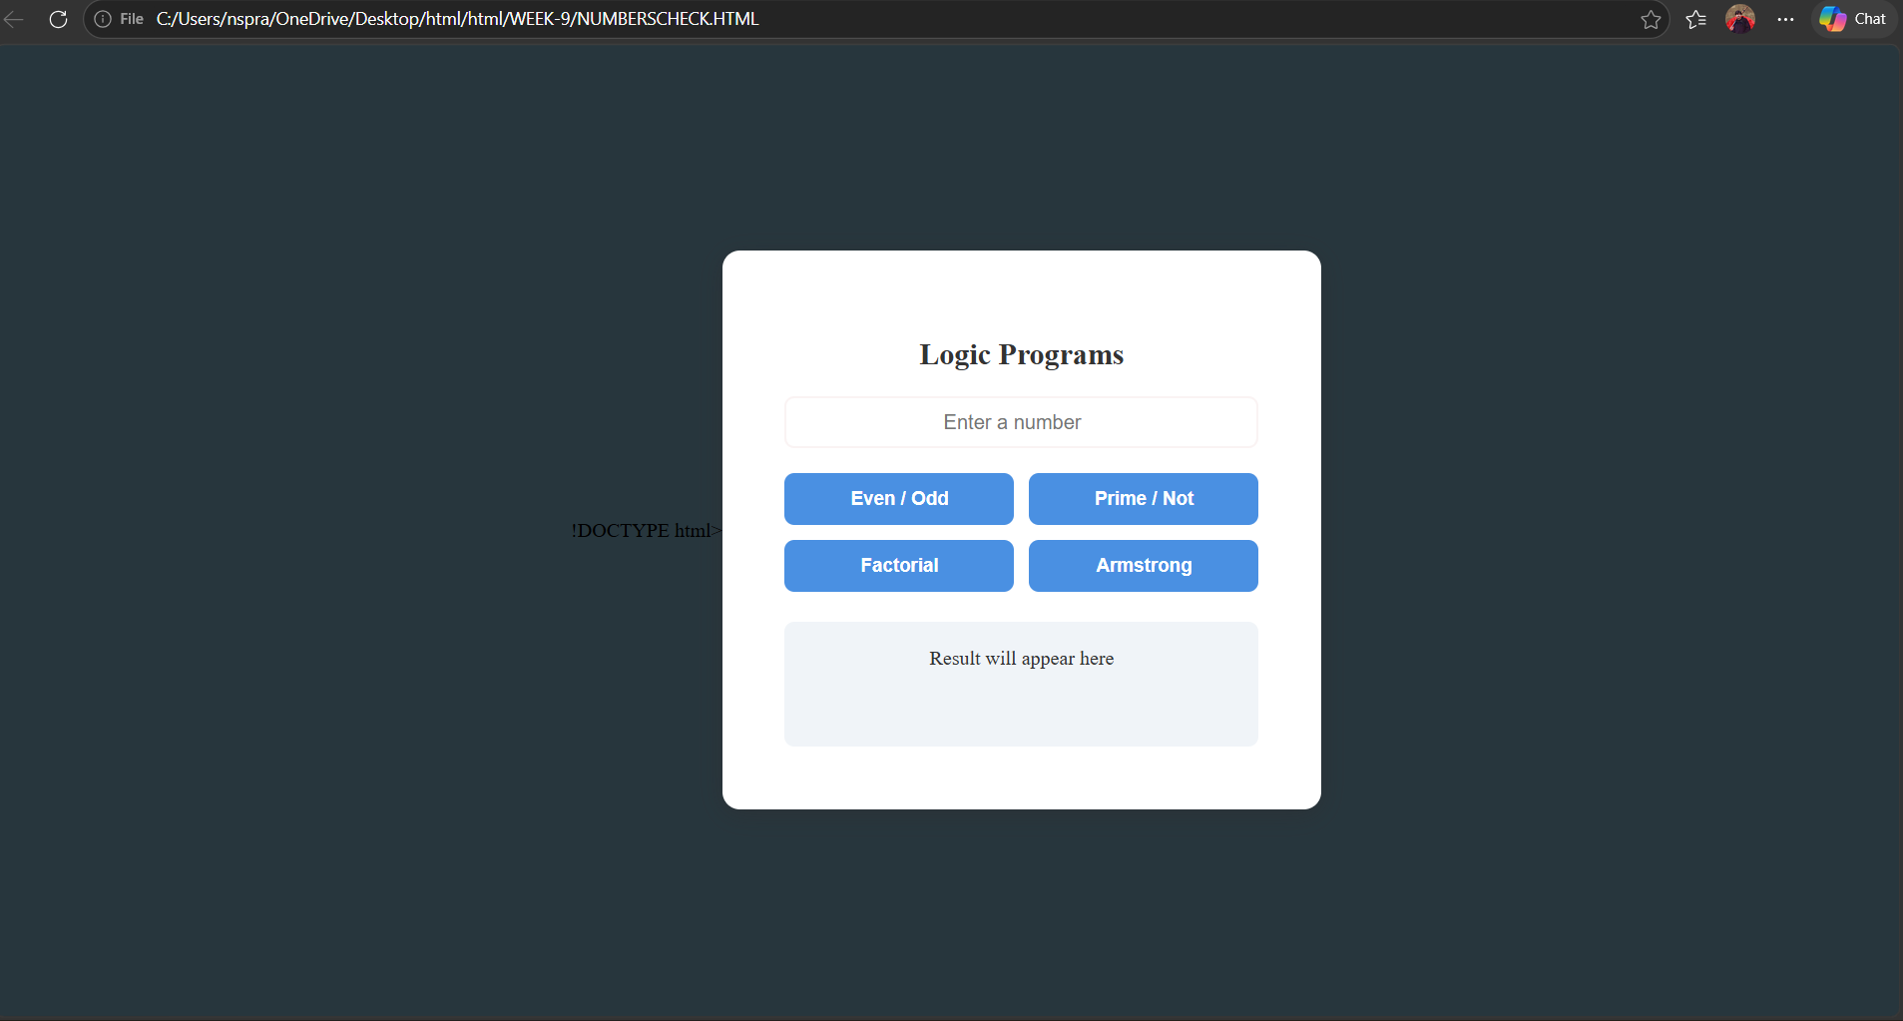
EXPLANATION:
<DOCTYPE html>: the <!DOCTYPE html> element tells the web browser that this an HTML documentor this is the latest version of HTML
<html>: the <html> element is the root element of an HTML web page
<head>: the <head> element will contain meta data about the HTML web page
<title>: the <title> element specifies a title for the HTML Page
<body>: the <body> element contains all visible content all visible content like text, image, links,tables, etc
<h>: we used <h> element for heading
<div>:we use <div> element for encapsulating the divisions and easy to modify
<style>: the <style> element is used to write CSS (designing part) it controls colors, layout, spacing, etc
body: the body selector is used to design the whole page here it sets background color and centers the content
.container: used to design the main box (card)gives white background, padding, shadow and roundedcorners
input: used to design the input box width, padding, border and text alignment are set
button: used to design buttons gives color, size, border and hover effect
.output: used to design output box where result will be displayed
<input>: the <input> element is used to take user input type="number" allows only numbers id is used to access it in JavaScript
<div class="buttons">: groups all buttons together
<button>: used to perform actions when clicked onclick calls JavaScript functions
<div id="output">: used to display result initially shows "Result will appear here"
<script>: the <script> element is used to write JavaScript code it adds logic and functionality to the webpage
getElementById(): used to access HTML elements using id
.value: used to get value from input box
textContent: used to display or change text inside an element
function: used to define a block of code that performs a task
checkEvenOdd(): checks whether number is even or odd uses n % 2
checkPrime(): checks whether number is prime or not uses loop and division logic
calcFactorial(): calculates factorial of a number multiplies numbers from 1 to n
checkArmstrong(): checks Armstrong number sum of digits power equals number
Math.sqrt(): used to find square root (used in prime logic)
parseInt(): converts string to integer
isNaN(): checks if value is not a number

WEEK-10
10) )Aim: write JavaScript conditional statement to find the sign of product of three numbers using functions .Display an alert box with specified sign .write a java script conditional statements to sort 3 numbers using functions display an alert box to show the result.write a java script conditional statement to find largest of find largest of five numbers using function and onclick event .display an alert box to show the result .write a java script for loop that will iterate from 0 to 15. For each iteration ,it will check if the current number odd or even , and display a message on screen .write a java script program to read 6 subjects marks from the student then computes the average marks of students then , this average is used to determine the corresponding grade
CODE:
!DOCTYPE html>
<html>
<head>
<title>Logic Programs</title>
<style>
body {
font-family: Arial;
display: flex;
height: 100vh;
}
.left {
width: 30%;
background: beige;
padding: 20px;
border-right: 3px solid #ccc;
}
.right {
width: 70%;
background: #f5f5dc;
padding: 20px;
}
input {
width: 95%;
padding: 10px;
margin-bottom: 10px;
}
button {
width: 100%;
padding: 10px;
margin-bottom: 10px;
background: #d2b48c;

border: none;
cursor: pointer;
}
#output {
background: #fff8dc;
padding: 20px;
min-height: 200px;
white-space: pre-line;
}
</style>
</head>
<body>
<div class="left">
<h3>Enter Input</h3>
<input type="text" id="numbers" placeholder="Click a button to see input
format">
<button onclick="signProduct()">Sign of Product</button>
<button onclick="sortNumbers()">Sort Numbers</button>
<button onclick="largestNumber()">Largest Number</button>
<button onclick="oddEvenLoop()">Odd / Even 0-15</button>
<button onclick="studentGrade()">Student Grade</button>
</div>
<div class="right">
<h3>Output</h3>
<div id="output">Result will appear here</div>
</div>
<script>
function getNumbers() {
let input = document.getElementById("numbers").value;
return input.split(",").map(Number);
}
function signProduct() {
let input = document.getElementById("numbers").value;
if (input === "") {
document.getElementById("output").textContent =
"Enter 3 numbers like: 0,-1,4";
return;
}
let nums = getNumbers();
let negative = 0;
for (let n of nums) {
if (n < 0) negative++;

}
let result = (negative % 2 == 0) ? "+1" : "-1";
alert(result);
document.getElementById("output").textContent = "Sign: " + result;
}
function sortNumbers() {
let input = document.getElementById("numbers").value;
if (input === "") {
document.getElementById("output").textContent =
"Enter 3 numbers like: 0,-1,4";
return;
}
let nums = getNumbers();
nums.sort((a, b) => b - a);
alert(nums.join(", "));
document.getElementById("output").textContent =
"Sorted: " + nums.join(", ");
}
function largestNumber() {
let input = document.getElementById("numbers").value;
if (input === "") {
document.getElementById("output").textContent =
"Enter 5 numbers like: -5,-2,-6,0,-1";
return;
}
let nums = getNumbers();
let max = nums[0];
for (let n of nums) {
if (n > max) max = n;
}
alert("Largest: " + max);
document.getElementById("output").textContent =
"Largest: " + max;
}
function oddEvenLoop() {
let input = document.getElementById("numbers").value;
if (input === "") {
document.getElementById("output").textContent =
"Enter a number like: 15 (to check from 0 to that number)";
return;
}
let n = Number(input);

let result = "";
for (let i = 0; i <= n; i++) {
if (i % 2 == 0)
result += i + " is Even\n";
else
result += i + " is Odd\n";
}

document.getElementById("output").textContent = result;
}
function studentGrade() {
let input = document.getElementById("numbers").value;
if (input === "") {
document.getElementById("output").textContent =
"Enter 6 subject marks like: 70,80,90,60,75,85";
return;
}
let nums = getNumbers();
let sum = 0;
for (let n of nums) sum += n;
let avg = sum / nums.length;
let grade;
if (avg >= 90) grade = "A";
else if (avg >= 75) grade = "B";
else if (avg >= 60) grade = "C";
else grade = "D";
alert("Average: " + avg + " Grade: " + grade);
document.getElementById("output").textContent =
"Average: " + avg + " | Grade: " + grade;
}
</script>
</body>
</html>

OUTPUT:
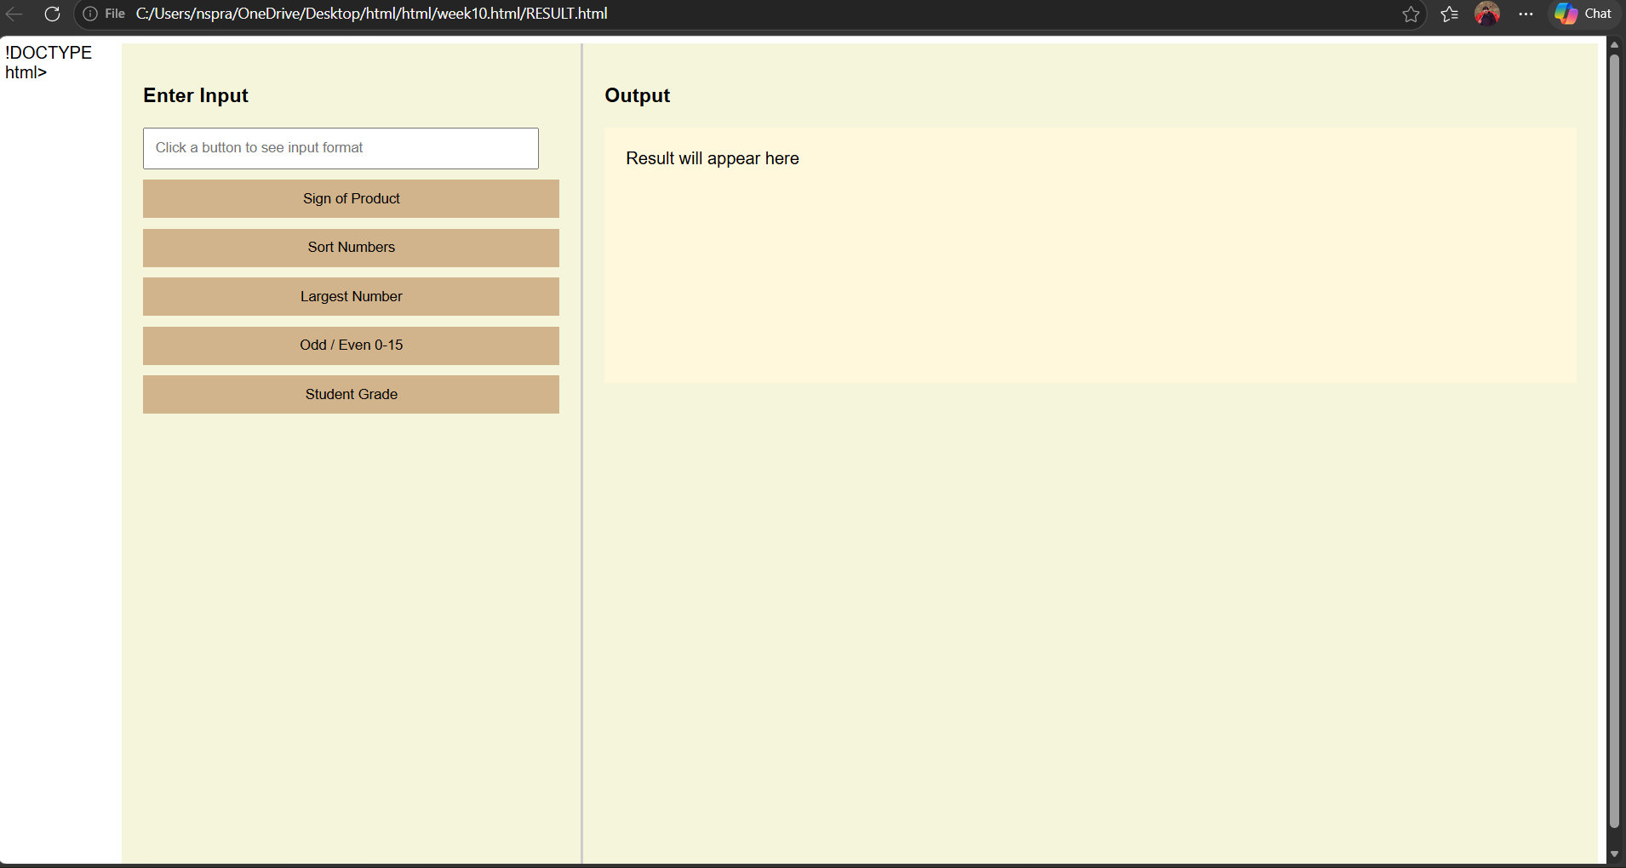
EXPLANATION:
<!DOCTYPE html> : the <!DOCTYPE html> element tells the browser that this is an HTML5 document
<html> : the <html> element is the root element of the web page all elements are written inside this
<head> : the <head> element contains meta information like title and styles
<title> : the <title> element specifies the name of the web page it appears on the browser tab
<style> : the <style> element is used to write CSS for designing the page
body : the body selector is used to style the whole page here flex is used to divide page into two sections
.left : this class is used for left side panel contains input box and buttons
.right : this class is used for right side panel used to display output
input : the <input> element is used to take user input here type="text" is used to enter numbers like 1,2,3
button : the <button> element is used to perform actions onclick is used to call JavaScript functions
<div> : the <div> element is used to group elements helps in layout design
#output : this is an id used to display result .textContent is used to change its text
<script> : the <script> element is used to write JavaScript code
function : used to define a block of code that performs a task
getElementById() : used to access HTML elements using id
.value : used to get value from input box
.split(",") : used to convert input string into array using comma
.map(Number) : converts string values into numbers
for loop : used to repeat code multiple times
if condition : used to check conditions
alert() : used to display popup message

WEEK-11
AIM:A website requires users to enter a username. The system should display a message while typing if the username is less than 5 characters.
CODE :
<!DOCTYPE html>
<html>
<head>
<title>Username Validation</title>
</head>
<body>

<h3>Enter Username:</h3>
<input type="text" id="username" onkeyup="checkUsername()">
<p id="msg"></p>

<script>
function checkUsername() {
let username = document.getElementById("username").value;
let msg = document.getElementById("msg");

if (username.length < 5) {
msg.innerHTML = "Username must be at least 5 characters";
msg.style.color = "red";
} else {
msg.innerHTML = "Valid username";
msg.style.color = "green";
}
}
</script>

</body>
</html>

OUTPUT:
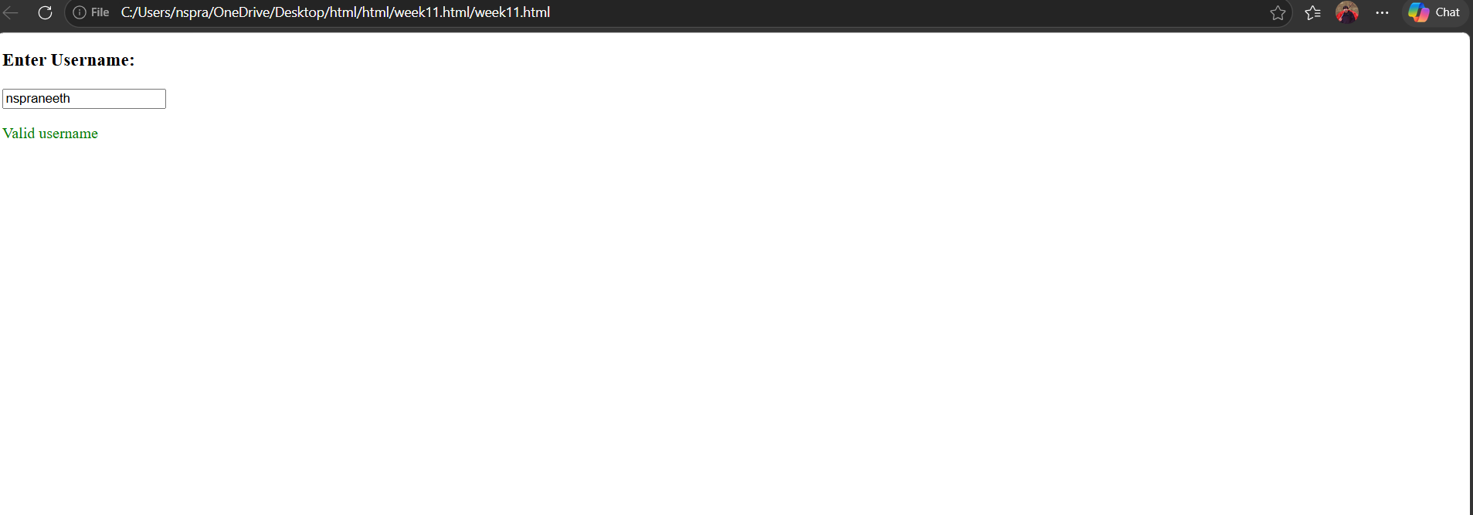
AIM:11B: 2. A registration form should validate email format before submission. If invalid, the form should not be submitted.
CODE :
<!DOCTYPE html>
<html>
<head>
<title>Email Validation</title>
</head>
<body>

<form onsubmit="return validateEmail()">
Email: <input type="text" id="email">
<input type="submit" value="Submit">
</form>

<p id="msg"></p>

<script>
function validateEmail() {
let email = document.getElementById("email").value;
let msg = document.getElementById("msg");

let pattern = /^[^ ]+@[^ ]+\.[a-z]{2,3}$/;

if (!email.match(pattern)) {
msg.innerHTML = "Invalid Email Format";
msg.style.color = "red";
return false; // stop submission
}
return true;
}
</script>

</body>
</html>

OUTPUT :
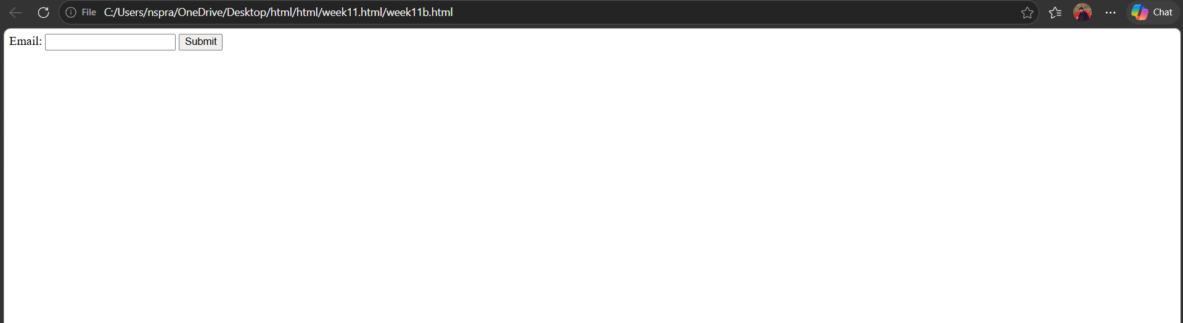
11C:AIM: A system should check password strength while typing and display whether it is weak or strong
CODE :
<!DOCTYPE html>
<html>
<head>
<title>Password Strength</title>
</head>
<body>

<h3>Enter Password:</h3>
<input type="password" id="password" onkeyup="checkPassword()">
<p id="msg"></p>

<script>
function checkPassword() {
let pass = document.getElementById("password").value;
let msg = document.getElementById("msg");

if (pass.length < 6) {
msg.innerHTML = "Weak Password";
msg.style.color = "red";
} else {
msg.innerHTML = "Strong Password";
msg.style.color = "green";
}
}
</script>

</body>
</html>

OUTPUT :
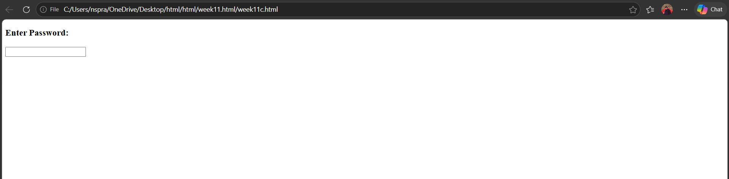

11D:AIM: A form should validate a mobile number when the user leaves the input field. The number must be exactly 10 digits.
CODE:
<!DOCTYPE html>
<html>
<head>
<title>Mobile Validation</title>
</head>
<body>

<h3>Enter Mobile Number:</h3>
<input type="text" id="mobile" onblur="validateMobile()">
<p id="msg"></p>

<script>
function validateMobile() {
let mobile = document.getElementById("mobile").value;
let msg = document.getElementById("msg");

let pattern = /^[0-9]{10}$/;

if (!mobile.match(pattern)) {
msg.innerHTML = "Enter a valid 10-digit mobile number";
msg.style.color = "red";
} else {
msg.innerHTML = "Valid mobile number";
msg.style.color = "green";
}
}
</script>

</body>
</html>

OUTPUT :
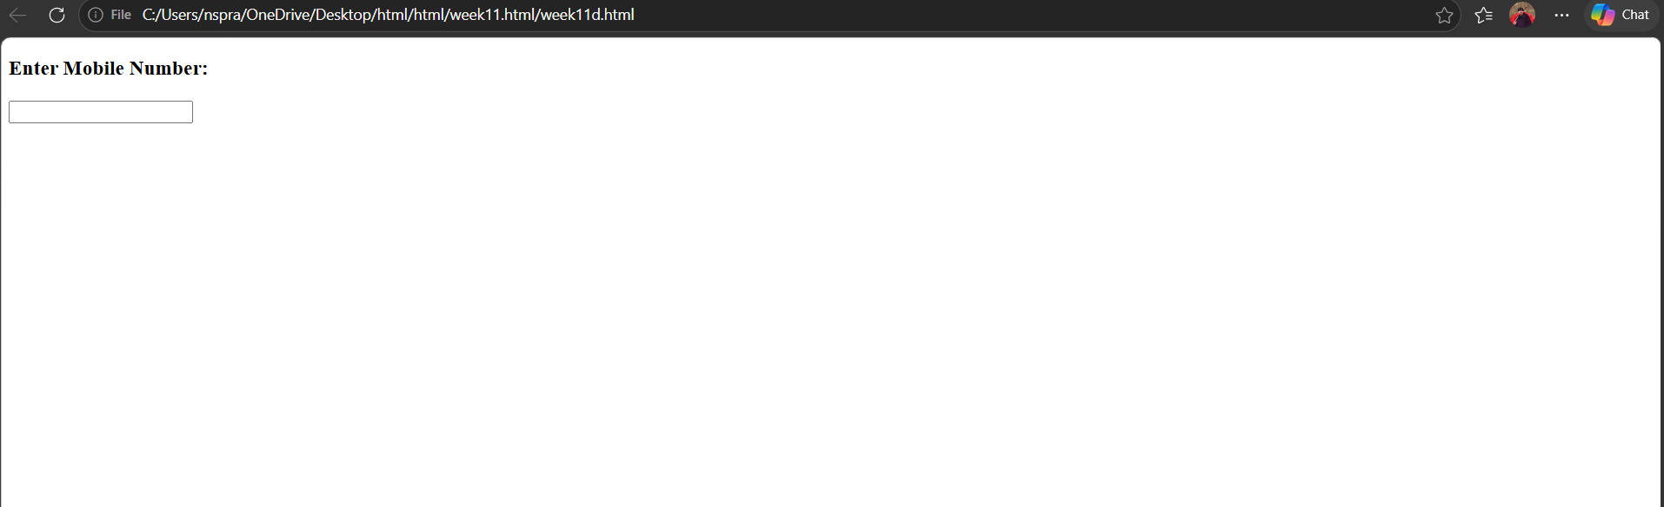

11E:AIM: 5. Design an HTML page, such that the registration form must validate:
Name (not empty)
Email (valid format)
Password (minimum 6 characters)
CODE :
<!DOCTYPE html>
<html>
<head>
<title>Registration Form</title>
</head>
<body>

<h2>Registration Form</h2>

<form onsubmit="return validateForm()">
Name: <input type="text" id="name"><br><br>
Email: <input type="text" id="email"><br><br>
Password: <input type="password" id="password"><br><br>
<input type="submit" value="Register">
</form>

<p id="msg"></p>

<script>
function validateForm() {
let name = document.getElementById("name").value;
let email = document.getElementById("email").value;
let password = document.getElementById("password").value;
let msg = document.getElementById("msg");

let emailPattern = /^[^ ]+@[^ ]+\.[a-z]{2,3}$/;

if (name === "") {
msg.innerHTML = "Name cannot be empty";
return false;
}

if (!email.match(emailPattern)) {
msg.innerHTML = "Invalid Email";
return false;
}

if (password.length < 6) {
msg.innerHTML = "Password must be at least 6 characters";
return false;
}

return true;
}
</script>

</body>
</html>

OUTPUT :
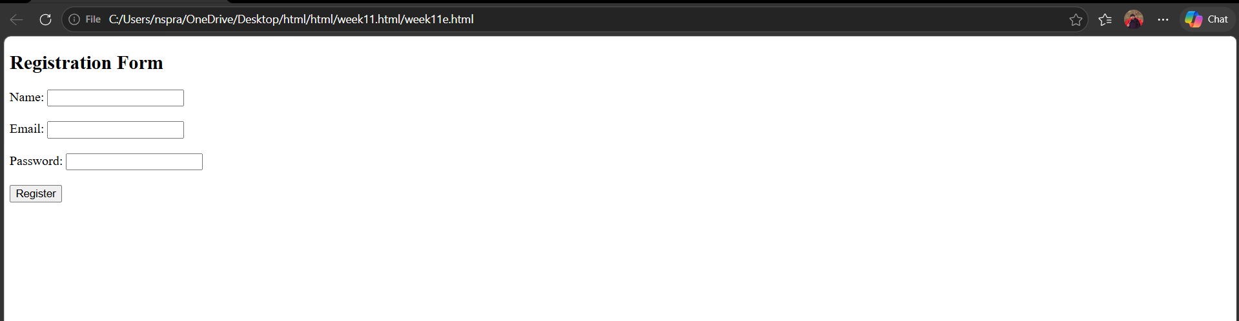

WEEK-12

Aim: Installation of electron
Steps for installation of electron:
Step1: Open Google Chrome browser.
Open:Node.js Official Website
Download the LTS version
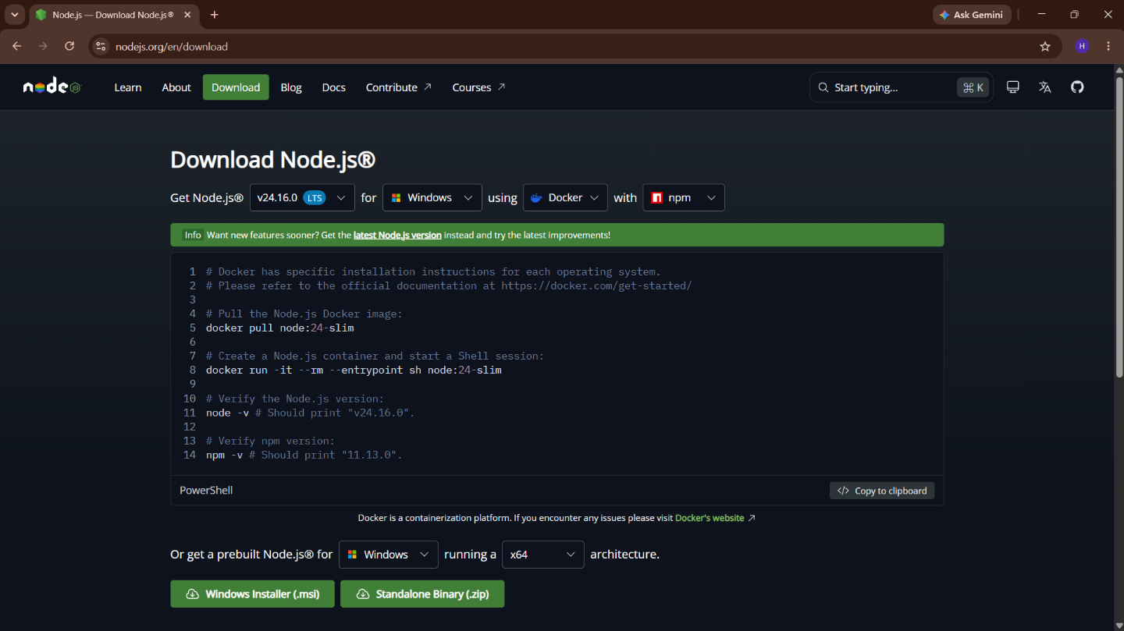

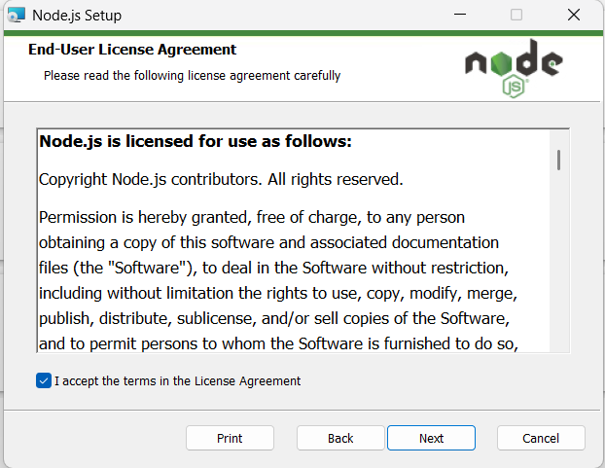
Node.js automatically installs:
- Node
npm (Node Package Manager)
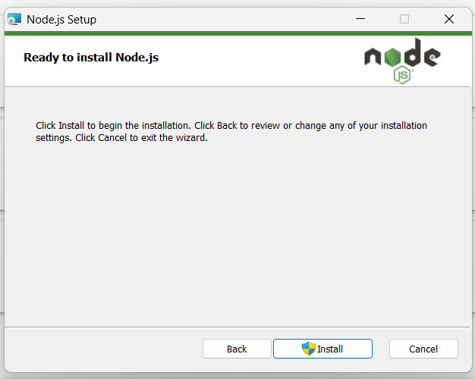

Step2:
Open VS Code.
Open terminal:
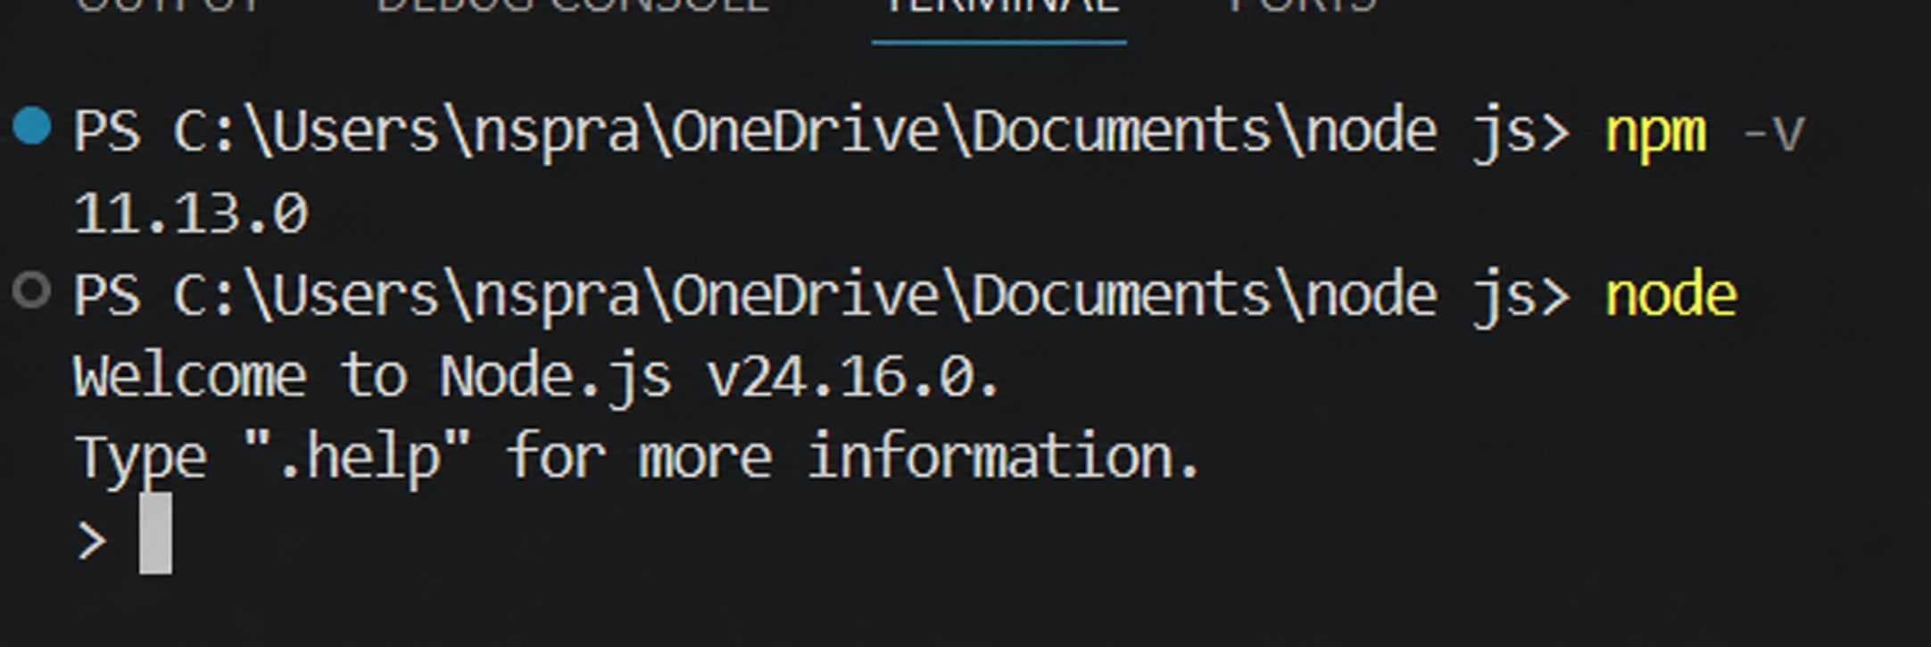

Step3:
Create New Empty Folder
- Create a new folder anywhere
Example:
ElectronApp
Step4 — Initialize Node Project
Run:
npm init -y
This creates:
package.json
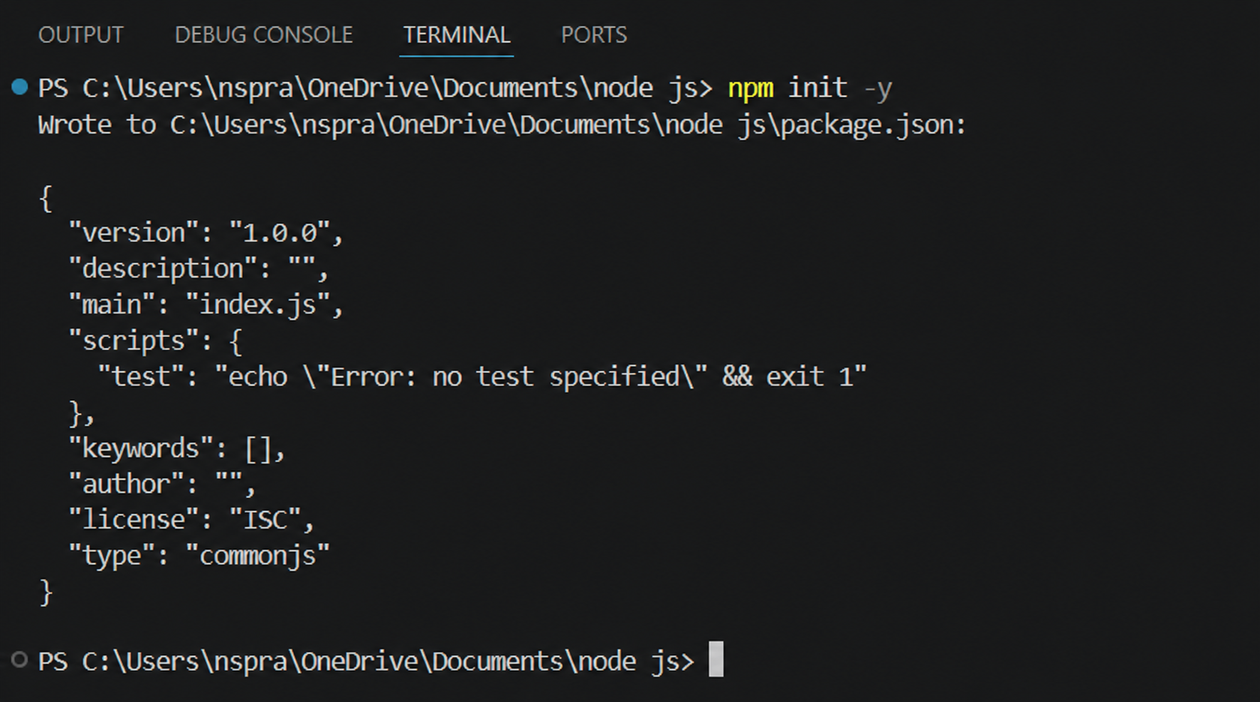
Step5 — Install Electron
Run:
npm install electron --save-dev
Wait until installation finishes
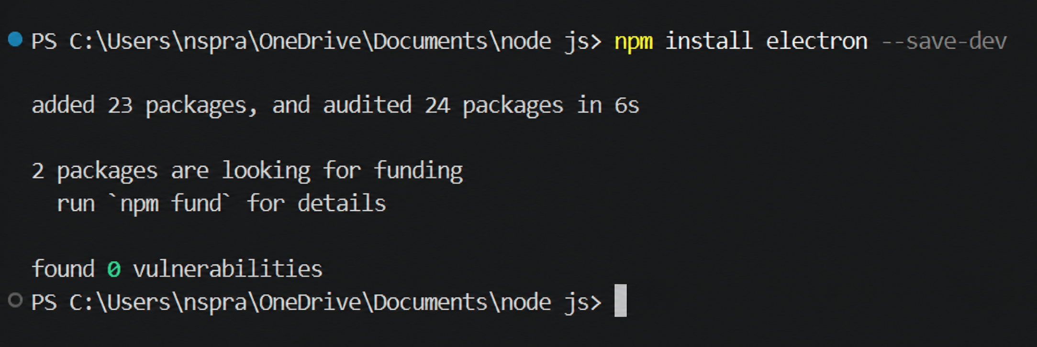

Step6 — Modify package.json
Open package.json
Add:
"main": "main.js",
Inside "scripts" add:
"start": "electron ."

Final example:
{
"name": "electronapp",
"version": "1.0.0",
"main": "main.js",
"scripts": {
"start": "electron ."
}
}

Step7 — Open Electron Official Website
Open Chrome.
Go to:
Electron.js Official Website
Navigate:
Docs → Tutorial → Building Your First App
Copy the Final Starter Code
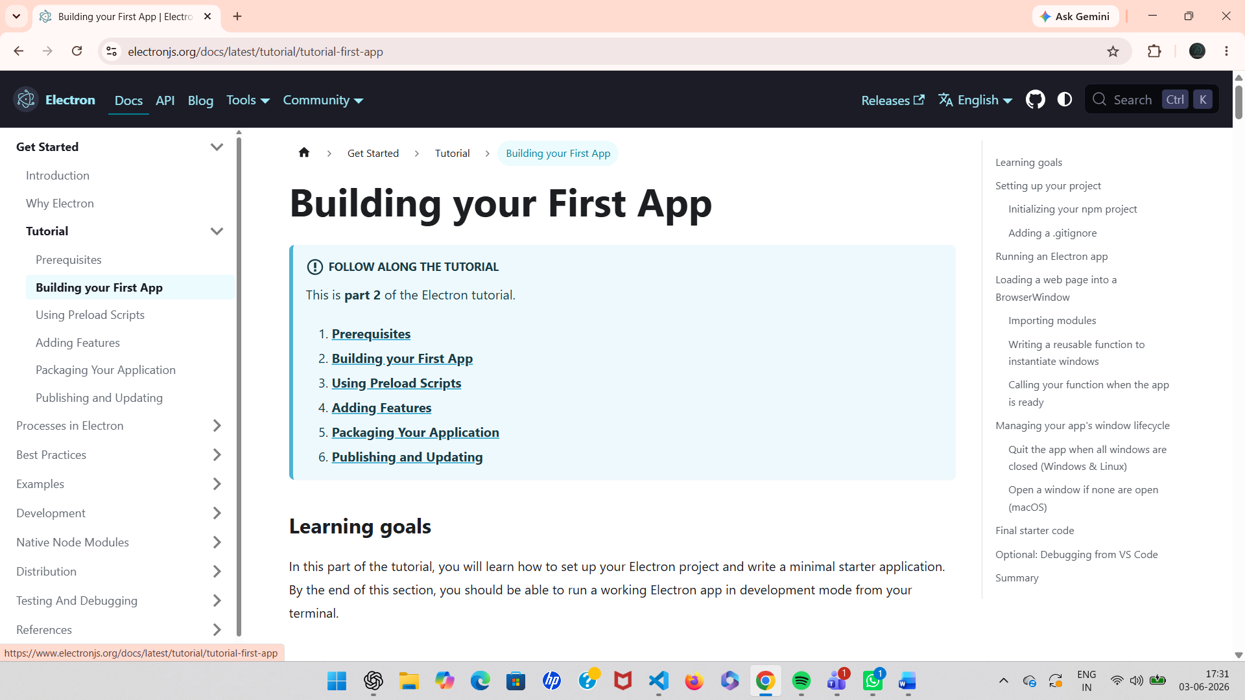
Step8 — Create Required Files
Inside your project folder create:
main.js
index.html
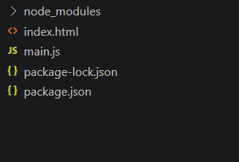

Step9 — Paste Electron Code in main.js
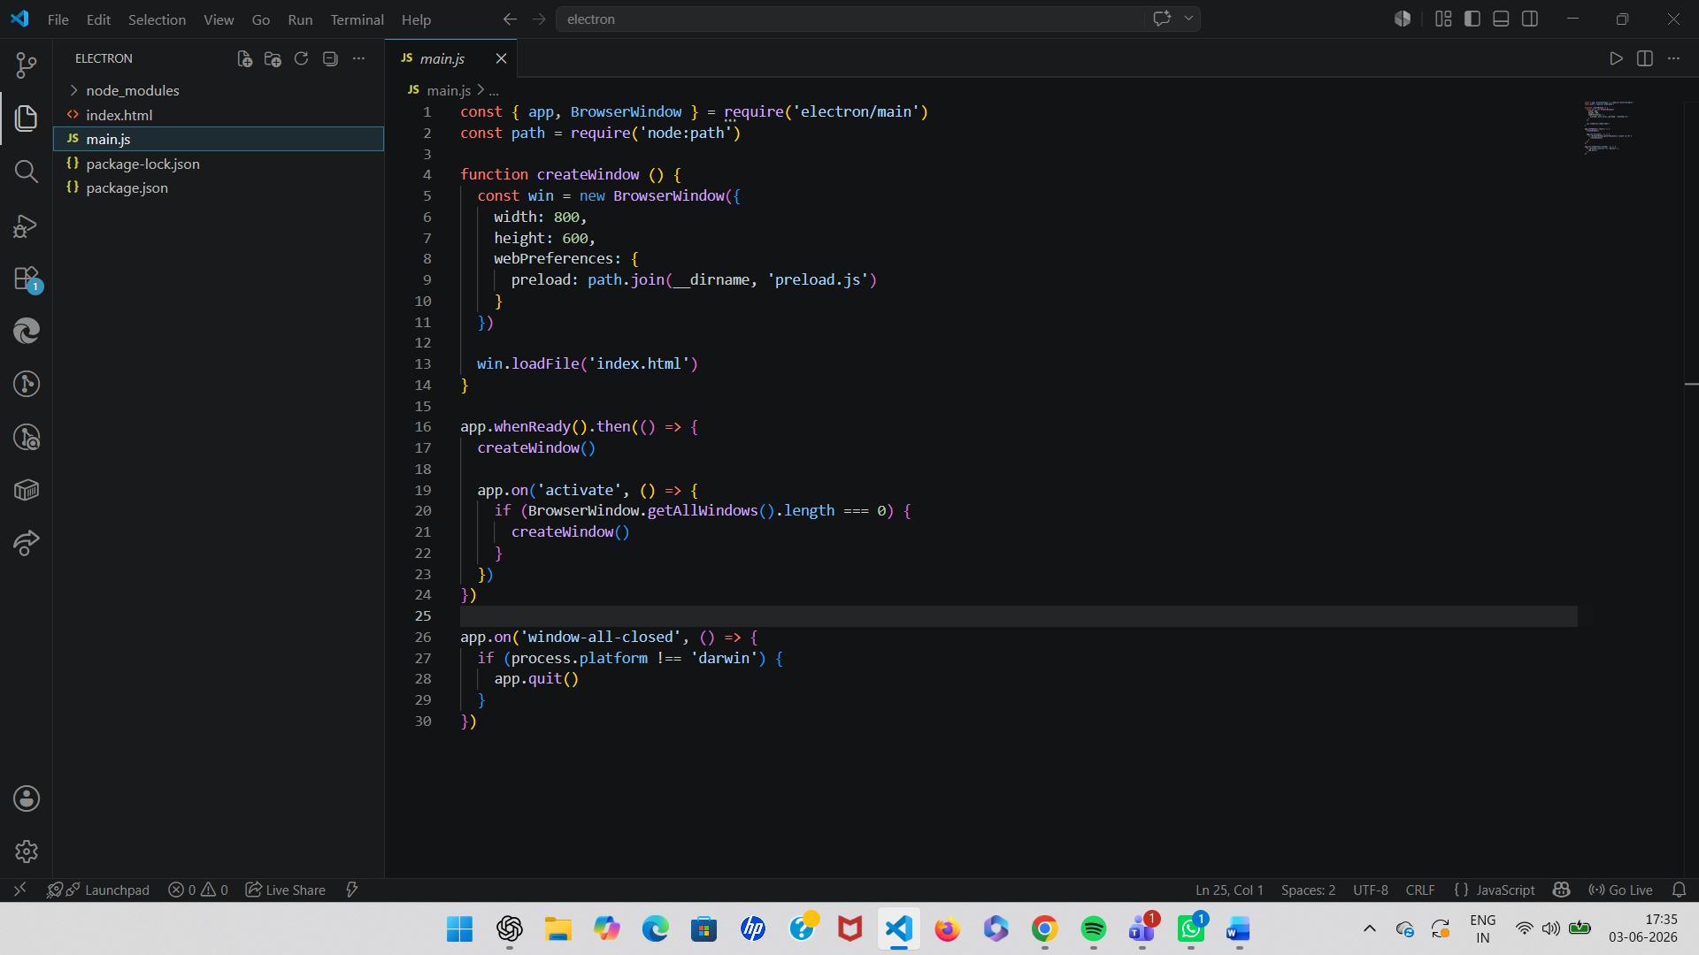
Step10 — Add HTML File
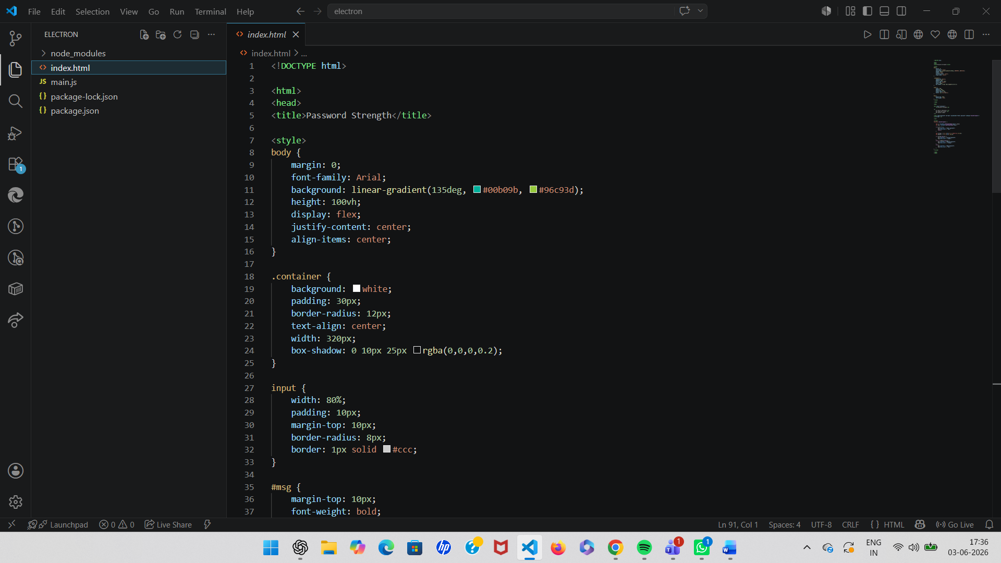

Step11 — Verify File Names
Make sure:
win.loadFile('index.html')
matches your actual HTML filename.

Step 12 — Run the Electron App
In terminal run:
npm start
Your Electron desktop app window will open

Description:

Description of Modules Used
1. Node.js
Node.js is a JavaScript runtime environment used to execute JavaScript code outside the browser. It provides the backend environment required for Electron applications. In this project, Node.js is used to initialize the project, install dependencies, and manage packages using npm.

2. npm (Node Package Manager)
npm is the default package manager for Node.js. It is used to install Electron and other required libraries into the project. Commands such as npm init -y, npm install electron --save-dev, and npm start are executed using npm.

3. Electron.js
Electron.js is an open-source framework used for building desktop applications using HTML, CSS, and JavaScript. It combines Chromium and Node.js, allowing web applications to run as desktop software on Windows, Linux, and macOS.

4. main.js
The main.js file is the main entry point of the Electron application. It creates the application window using the BrowserWindow module and controls the lifecycle of the desktop application.
Main functions of main.js:
- Creates the application window
- Loads the HTML file
- Handles application startup and closing events

5. BrowserWindow Module
BrowserWindow is an Electron module used to create and manage desktop windows. It allows the application to display web pages inside a native desktop window.
Features:
- Set window size
- Load HTML pages
- Control window behavior

6. app Module
The app module controls the overall lifecycle of the Electron application. It handles events such as:
- Application startup
- Closing windows
- Activating the application

7. package.json
The package.json file contains project information and configuration details. It stores:
- Project name and version
- Installed dependencies
- Main entry file
- Scripts used to run the application

8. index.html
The index.html file contains the user interface of the Electron application. It is loaded inside the Electron window and displays the frontend content using HTML and CSS.

9. preload.js
The preload.js file acts as a bridge between the renderer process and Node.js environment. It is executed before the web page loads and is commonly used for secure communication between frontend and backend components.

Introduction to Electron.js
Electron.js is an open-source framework used to build cross-platform desktop applications using web technologies such as HTML, CSS, and JavaScript. It was developed and maintained by Electron.js.
Electron combines two major technologies:
- Chromium browser engine for the user interface
- Node.js runtime for backend and system-level operations
This allows developers to create desktop applications using the same technologies used for web development.
Applications built with Electron can run on:
- Windows
- macOS
- Linux
Electron is widely used for developing modern desktop applications because it provides:
- Easy development process
- Cross-platform compatibility
- Access to native system features
- Support for modern web technologies
Popular applications built using Electron include:
- Visual Studio Code
- Discord
- Slack
- WhatsApp Desktop
- Spotify Desktop
In this project, Electron is used to create a desktop application by setting up a Node.js project, installing Electron through npm, and running the application using the Electron runtime.

